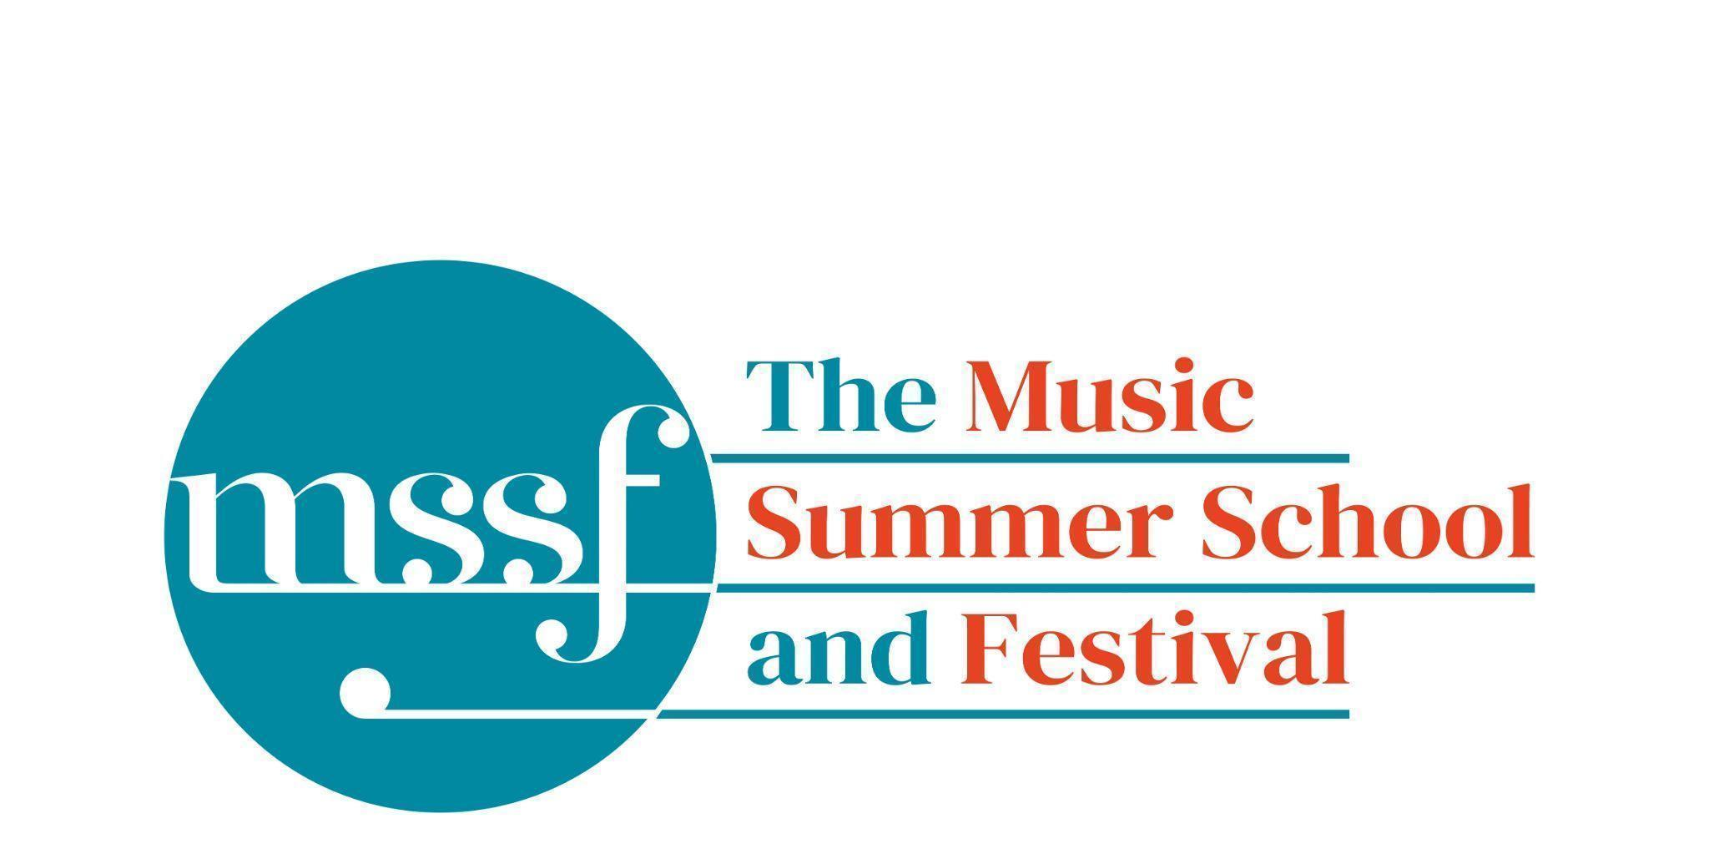

Daily Programme
Wednesday 12 August 2026
Tai-Chi - Moving Meditation  With Doris Schierer | Chapel Lawn | 7.15am to 7.45am - the gentle exercise of Tai-Chi helps to improve  balance and co-ordination.

Session 1 (09:00-10:30)
Choir : Haydn’s Harmoniemesse  Britten’s Jubilate Deo and Te Deum  directed by Graham Ross | Chapel
Percussion Ensemble  directed by Ensemble Bash | B1 and B9  (Britten Building)
Light Orchestra  directed by Steve Dummer | Big School Hall | Please bring a stand
Advanced Chamber Music  directed by Wihan Quartet | Various | BS1, BS2, BS3, BS5, B10, B17, B18/19, B20, Reith 3, Fishmongers Hall
Brass Ensemble  directed by Paul Archibald & Donal Bannister | Reith Study Room 1 | This is on the 2nd floor. There is a lift at the end of the left corridor  (choose floor 3)
Chamber Music  directed by Rhiannon Evans | Various | Tallis Common Room, BS4, BS15, D104

Morning Break (10:30 – 11:00)
Session 2 (11:00-12:30)

Voice  directed by Claire Booth | Elephant Steps  (Dyson Building)
Chamber Music  directed by Rhiannon Evans, Tim Horton, Wihan Quartet | Various | BS1, BS2, BS3, BS4, BS5
Wind Band  directed by Steve Dummer | Big School Hall
Opera Ensemble  directed by Pippa Dames Longworth,  Ian Rutherford & Andrew Smith | Auden Theatre & Fairfield Common Room
Piano  directed by Florian Mitrea | Fishmongers Hall
Chamber Choir: Shearing - Songs and Sonnets  Elgar - From the Bavarian Highlands  directed by Gavin Roberts | Chapel
Double Bass  directed by Levi Andreassen | BS15  (Big School)
Cello  directed by Gemma Rosefield | B18/19  (Britten Building)
Viola  directed by Rachel Robert | B20  (Britten Building)
Violin  directed by Benjamin Nabarro | B17  (Britten Building)
Tango Orchestra  directed by Mirek Salmon, Caroline Pearsall,  Daryl Kellie | Tallis Common Room | Code for Tallis is 962375

NB: ALL SESSIONS FROM THIS POINT UNTIL 7.30PM ARE SCHEDULED
30 MINUTES EARLIER FOR OUR ECLIPSE EVENT
Lunch Break (12:30 – 13:30)
Ballroom Dancing  With Doris Schierer | BS15  Big School | 13:00 - 13:30 Learn and dance the basic moves in all the popular Ballroom and Latin American styles that look sooo easy on Strictly. Whether you're completely new to it, want a refresher or are a regular dancer keeping in practice, everyone's welcome! No partner needed for this drop in session.

Session 3 (13:30-15:00)
Voice  directed by Sarah Gabriel | D1.04  (Dyson Building)
Percussion  directed by Ensemble Bash | B1 Percussion Room & B9  (Britten Building)
Flute  Directed by Nancy Ruffer | B17  (Britten Building)
Trombone  directed by Donal Bannister | B18/19  (Britten Building)
Collaborative Piano  directed by Anna Tilbrook | Big School Hall
The Lone Voice - works for unaccompanied voice  directed by Claire Booth | Elephant Steps  (Dyson Building)
Chamber Music  directed by Rhiannon Evans,  Tim Horton & Wihan Quartet | BS2, BS3, BS5  (Big School)
Opera Ensemble  directed by Pippa Dames Longworth, Ian Rutherford & Andrew Smith | Auden Theatre
String Ensemble  directed by Gemma Rosefield, Levi Andreasson, Benjamin Nabarro, Rachel Roberts | Reith 5  (Reith Building)
Piano  Directed by Florian Mitrea | Fishmongers Hall  (Britten Building)
Horn  directed by Benjamin Hartnell-Booth | D1.14  (Dyson Building)
Trumpet  directed by Paul Archibald | D1.17  (Dyson Building)
Bassoon  directed by Angharad Thomas | B10 - Shaw  (Britten Building)
Oboe  Directed by Adrian Wilson | B20  (Britten Building)
Clarinet  directed by Robert Plane | BS1  (Big School)
Tango Orchestra  directed by Mirek Salmon, Daryl Kellie,  Caroline Pearsall | Tallis Common Room | Code for Tallis is 962375
The Complete Saxophone Course  directed by Huw Wiggin | BS15  (Big School)

Session 4 (16:00-17:00)
Pure Imagination  directed by Sarah Gabriel | Elephant Steps  (Dyson Building)
West Africa Drumming  directed by Richard Benjafield | B1, B9, B10  (Britten Building)
Classical Orchestra  directed by Graham Ross | Big School Hall
Choir Notes and Confidence Workshop  directed by Gavin Roberts | D1.04  (Dyson Building)
Saxophone Ensemble  directed by Huw Wiggin | D1.07  (Dyson Building) | Please note change of venue
Tango Dance  directed by John Mason | Tallis Common Room | Code for Tallis is 962375
Opera Ensemble Orchestra  directed by Steve Dummer | Reith 5  (Reith Building)
Chamber Music  directed by Rhiannon Evans, Anna Tilbrook, Ensemble 360,  Nancy Ruffer | B17, B18/19, B20  BS1, BS2, BS3, BS4, BS5, BS15
Opera Ensemble  directed by Pippa Dames Longworth, Ian Rutherford, Andrew Smith | Auden Theatre & Fairfield Common Room

Wednesday 12 August 2026 - Concerts and Talks
Are you ready for this Evening of Stars?!

16:45  CONCERT  Huw Wiggin - saxophone  Marcus Andrews - piano  Thomas Carr - piano  ‘Night Flights and Fairy Tales’ | Fishmongers’ Hall | Iain Farrington – Paganini Patterns  Joseph Phibbs – Night Paths  Witold Lutosławski – Paganini Variations  Takashi Yoshimatsu – ‘Sing, Bird’  Francis Poulenc – l’embarquement pour Cythère, valse – musette for two pianos  Graham Fitkin – Hard Fairy  Paganini’s legacy serves as a structural and aesthetic point of reference, linking works that approach transformation, texture, and ensemble from distinct compositional perspectives.

ECLIPSE!
On the Cricket Lawn (Get your eclipse glasses at the Summer School office - £2 while stocks last
18:17 First Contact
18:25 Anna Tilbrook and Tim Horton - pianos
Holst - The Planets
19:11 Maximum Obscurance

19:30  CONCERT  Mirek Salmon - bandoneon  Caroline Pearsall - violin  Daryl Kellie - guitar | Chapel | ‘A Night of Tango’  A concert of music from the earliest known tangos to the golden age of the orquestra and beyond. Hear the evolution of tango music and its journey from the bordello to the concert hall featuring music by Gardeł, Piazzolla, Troilo and others with some surprises along the way.
The Evening of Stars continues…

21:30  CONCERT  Ensemble 360  ‘Spark to Fire’ | Auden Theatre | Ludwig van Beethoven – Quintet in Eb major for Piano and Winds, Op.16  Johannes Brahms – Piano Quartet No.1 in G minor, Op.25  Depth, drama and exhilarating ensemble playing shine in music of passion and irresistible drive.

It’s not over yet…

03:00  Perseid Meteor Storm  The best conditions in a decade | Somewhere dark with lots of sky | The Perseid meteor shower peaks overnight on 12 - 13 August with the maximum predicted for around 3am. Under a dark clear sky expect 50 - 100 meteors an hour at the peak, including bright fireballs.

Office Opening Hours (Dyson Building, Room D0.05)
Saturday | 8.30am - 10am | 2pm – 6.30pm
Sunday | 8.30am - 12.45pm | 1.45pm - 5.30pm
Monday - Friday | 8.45am – 12.45pm | 1.45pm - 5.30pm

Practice Rooms and Studio Booking Times:
All studios and practice rooms are open 8am – 10pm. Booking sheets for practice rooms are posted at 1.45pm daily on each practice room for the following day. Larger spaces are sometimes available for practice and can be booked with the Summer School Office Manager – please enquire in the Summer School Office in the Dyson Building (Room D0.05) for availability. These can be booked from 1.45pm for the following day (and from 8.30am on Sunday for Sunday bookings).
The instrument store room is located next door to the Summer School Office in the Dyson Building, Room D0.04.
Cafe and Bar Opening Hours: Tigs Café, situated in the Britten Building, is open from 10am to 4pm every day. The Auden Theatre Bar is open from 4pm to 11pm every day (midnight on Fridays).
Available in the Cafe - Wraps, Cakes, Light Meals - Hot and Cold Drinks - Ice Cream
Wine at dinner is available to purchase by the glass (£6.50) or bottle (£22) during dinner. Unfinished bottles can be labelled and kept in the fridge so that you can finish it off another evening.
Croquet - the croquet set is available to borrow from the Summer School Office (Dyson Building, Room D0.05) during office hours.
Swimming - The swimming pool, included in your summer school package, is open from 6.00am-8.30am and from 4pm-6pm.

