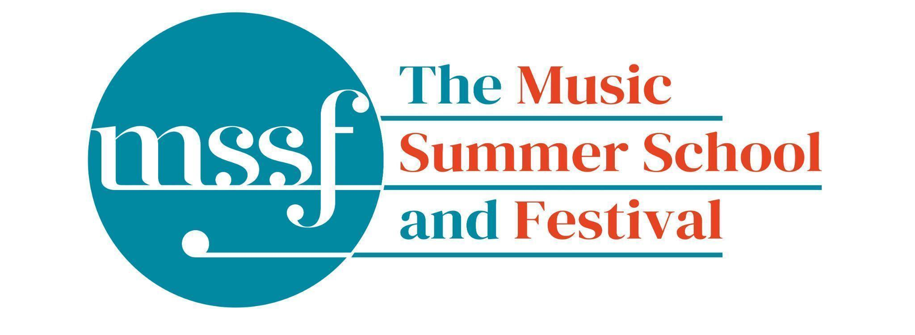
Daily Programme

Tuesday 4 August 2026
Tai-Chi - Moving Meditation  With Doris Schierer | Chapel Lawn | 7.15am to 7.45am - the gentle exercise of Tai-Chi helps to improve balance and co-ordination.

Session 1 (09:00-10:30)
Choir: Rameau, Bach, Schütz, Schein & Handel  directed by Robert Hollingworth | Chapel
Orchestral Workshop  directed by Rhiannon Evans | BS5  Big School | Please note change of venue
Chamber Music  directed by Rhiannon Evans | BS4 & BS3  Big School | Please note change of venue
Advanced Baroque Chamber Music  directed by The Brook Street Band | Big School Hall & BS2  Big School | Please note change of venue
Viol Consorts  directed by Gavin Kibble | BS14  Big School
Big Band  directed by Steve Dummer | Tallis Common Room | Code for Tallis is 962375
Composition for violin and electronics  directed by Pierre-Alexandre Tremblay &  Darragh Morgan | B9 ‘Greatorex’  Britten Building | Please note change of venue

Morning Break (10:30 – 11:00)

Session 2 (11:00-12:30)
Vocal Ensembles – Monteverdi and Wilbye  directed by I Fagiolini | Dyson Building  (first floor)
Baroque Orchestra  directed by Steven Devine, Conor Gricmanis,  Gavin Kibble & Gail Hennessy | Big School Hall | Fasch, Telemann and Bach
Triumphans : Music for Grand Occasions,  Ceremonies and Feasts, 1520 to 1620  directed by The City Musick | Reith Building  Reith 5 | This is on the first floor. There is a lift to the left of the main entrance (choose level 1). This session is for instrumentalists only.
Voice  directed by James Gilchrist | Auden Theatre
To Stand Up and Sing  directed by Kate Semmens | Elephant Steps  Dyson Building
Harpsichord  directed by Jane Chapman | BS1  Big School
Collaborative Piano  directed by Anna Tilbrook | Fishmongers’ Hall  Britten Building | Please note change of venue
Jazz Ensemble  directed by Derek Nash, Marc Cecil, Paul Higgs  & Trudy Kerr | Tallis Common Room | Code for Tallis is 962375
Chamber Music  directed by Rhiannon Evans & The Brook Street Band | BS2, BS4 & BS5  Big School
Folk Song Writing  directed by Adam Clark & Nic Zuppardi | Reith Building  Study Room 1 | This is on the second floor. There is a lift to the left of the main entrance (choose level 3).
Composition for violin and electronics  directed by Pierre-Alexandre Tremblay  & Darragh Morgan | B9 ‘Greatorex’  Britten Building
Organ  directed by David Titterington | Little Walsingham Church

Lunch Break (12:30 – 14:00)
Ballroom Dancing  With Doris Schierer | BS15  Big School | 13:10 - 13:40 Everyone’s welcome to drop in, no partner needed.  Learn and dance the basic moves in all the popular Ballroom and Latin American styles that look sooo easy on Strictly. Whether you're completely new to it, want a refresher or are a regular dancer keeping in practice, everyone's welcome!
TALK: Die Schӧne Müllerin  With James Gilchrist | Elephant Steps  Dyson Building | 13:20 - 13:50 In advance of his performance of Schubert’s Die Schӧne Müllerin, James Gilchrist gives his insights on the stories and the themes.  Everyone welcome!

Session 3 (14:00-15:30)
Vocal Ensembles – The Lyons Den: The Voice Unleashed  directed by The Lyons Mouth | Dyson Building  (first floor)
Song: German Lied  directed by James Gilchrist & Anna Tilbrook | Fishmongers’ Hall  Britten Building | Please note change of venue
Folk Music Ensemble  directed by Adam Clark & Nic Zuppardi | Reith Building  Study Room 1 | This is on the second floor. There is a lift to the left of the main entrance (choose level 3).
Baroque Orchestra  directed by Steven Devine, Conor Gricmanis,  Gavin Kibble & Gail Hennessy | Big School Hall | Fasch, Telemann and Bach
Jazz Ensemble  directed by Derek Nash, Marc Cecil, Paul Higgs  & Trudy Kerr | Tallis Common Room | Code for Tallis is 962375
Organ  directed by David Titterington | Little Walsingham Church
Harpsichord  directed by Jane Chapman | BS1  Big School
Triumphans : Music for Grand Occasions, Ceremonies and Feasts, 1520 to 1620  directed by The City Musick | Reith Building  Reith 5 | This is on the first floor. There is a lift to the left of the main entrance (choose level 1). This session is for instrumentalists and singers.
To Stand Up and Sing  directed by Kate Semmens | Auden Theatre
Jam Band  directed by Steve Dummer | BS15  Big School
Composition for violin and electronics  directed by Pierre-Alexandre Tremblay &  Darragh Morgan | B9 ‘Greatorex’  Britten Building
Chamber Music  directed by Rhiannon Evans & The Brook Street Band | BS4 & BS5  Big School

Session 4 (16:00-17:00)
Find your Voice  directed by I Fagiolini & The Lyons Mouth | Reith Building  Goff Lecture Theatre (R3) | The world is charged by Joanna Marsh
Folk Music Ensemble  directed by Adam Clark & Nic Zuppardi | Reith Building  Study Room 2 | This is on the second floor. There is a lift to the left of the main entrance (choose level 3).
Baroque Orchestra  directed by Steven Devine, Conor Gricmanis,  Gavin Kibble & Gail Hennessy | Big School Hall | Fasch, Telemann and Bach
Recorder Consorts  directed by Rhiannon Evans & Naomi Okuda Wooderson | D1.04  Dyson Building  (first floor)
Advanced Jazz Improvisation  directed by Derek Nash | Tallis Common Room | Code for Tallis is 962375
Jazz A Cappella Voice  directed by Trudy Kerr | B18 & B19  Britten Building
An Introduction to Improvisation  directed by Steve Dummer | BS15  Big School
Choir Notes and Confidence  directed by Gavin Roberts | Elephant Steps  Dyson Building
Chamber Music  directed by Rhiannon Evans & The Brook Street Band | BS2, BS3 & BS4  Big School | Please see separate notice in the Dining Room, Summer School office and on Whova.

Tuesday 4th August 2026 - Concerts and Talks

17:15  CONCERT  Adam Clark - Guitar  Nic Zuppardi - mandolin  ‘Lutestring’ | Fishmongers’ Hall | Norfolk native, Adam Clark and Nic Zuppardi, play a range of folk tunes and songs drawn from British and American traditions, including music from their latest project Lutestring, a suite of original tunes and prints inspired by British moths, described as ‘ a delightful blend of folk music and nature in perfect harmony’ (Songlines). Expect a mix of traditional, composed and improvised bluegrass, swing, old-time and East Anglian material, performed on mandolin, guitar, banjo and voice.
19:30  CONCERT  The Brook Street Band  ‘The Magic Hour’ | Chapel | There are times and places, liminal spaces, where the veil between worlds is thin. Travel with us through magical dimensions at dusk, following winding overgrown paths, glimpsing faeries and sprites, perhaps sensing ghosts and spirits. Let beautiful baroque chamber music by Bach, Handel, Purcell, Rebel and others take you through this magic hour. The programme opens with a Suite from Handel’s magic opera Alcina. Fairies and sprites come courtesy of Purcell, a few Elements from Rebel, a huge Bach Passacaglia features, plus much more.
21:30  CONCERT  Gavin Kibble - viola da gamba  Steven Devine - harpsichord  ‘Tous Les Soirs de Norfolk’ | Chapel | Music from the second book of Marin Marais  Marin Marais was recognised in his lifetime as the leading performer and composer of music for the viola da gamba, whose works were ‘known through the whole of Europe’. In Tous Les Soirs de Norfolk, Gavin Kibble brings to life music from Marais’s Second Book, with dances and character pieces which range from courtly elegance to profound introspection. This is music of intimacy and refinement within which ‘one recognizes the fecundity and elegance of the genius of this musician by the quantity of works he has composed. One finds everywhere in them good taste and a surprising variety.’

Office Opening Hours (Dyson Building, Room D0.05)
Saturday | 8.30am - 10am | 2pm – 6.30pm
Sunday | 8.30am - 12.45pm | 1.45pm - 5.30pm
Monday - Friday | 8.45am – 12.45pm | 1.45pm - 5.30pm

Practice Rooms and Studio Booking Times:
All studios and practice rooms are open 8am – 10pm. Booking sheets for practice rooms are posted at 1.45pm daily on each practice room for the following day. Larger spaces are sometimes available for practice and can be booked with the Summer School Office Manager – please enquire in the Summer School Office in the Dyson Building (Room D0.05) for availability. These can be booked from 1.45pm for the following day (and from 8.30am on Sunday for Sunday bookings).
The instrument store room is located next door to the Summer School Office in the Dyson Building, Room D0.04.
Cafe and Bar Opening Hours: Tigs Café, situated in the Britten Building, is open from 10am to 4pm every day. The Auden Theatre Bar is open from 4pm to 11pm every day (midnight on Fridays).
Available in the Cafe - Wraps, Cakes, Light Meals - Hot and Cold Drinks - Ice Cream
Wine at dinner is available to purchase by the glass (£6.50) or bottle (£22) during dinner. Unfinished bottles can be labelled and kept in the fridge so that you can finish it off another evening.
Croquet - the croquet set is available to borrow from the Summer School Office (Dyson Building, Room D0.05) during office hours.
Swimming - The swimming pool, included in your summer school package, is open from 6.30am-8.30am and from 4pm-6pm.

