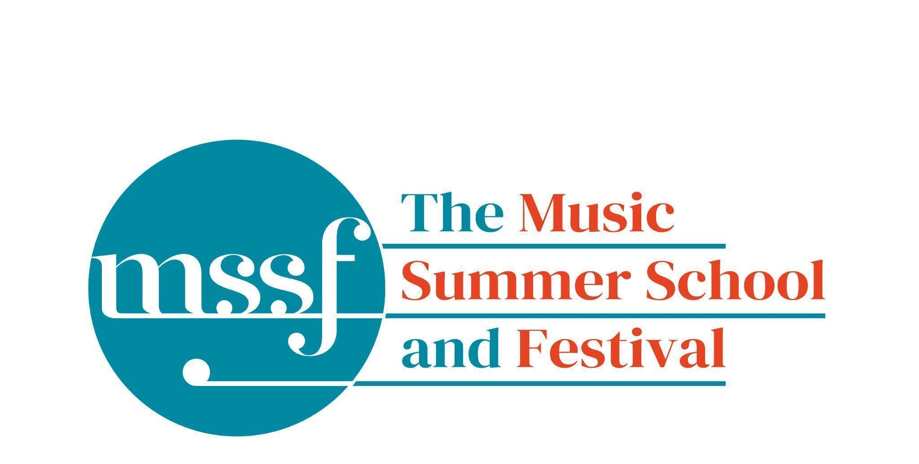

Daily Programme
Tuesday 11 August 2026
Tai-Chi - Moving Meditation  With Doris Schierer | Chapel Lawn | 7.15am to 7.45am - the gentle exercise of Tai-Chi helps to improve  balance and co-ordination.

Session 1 (09:00-10:30)
Choir : Haydn’s Harmoniemesse  Britten’s Jubilate Deo and Te Deum  directed by Graham Ross | Chapel
Percussion Ensemble  directed by Ensemble Bash | B1 and B9  (Britten Building)
Light Orchestra  directed by Steve Dummer | Big School Hall | Please bring a stand
Advanced Chamber Music  directed by Wihan Quartet | Various | BS1, BS2, BS3, BS5, B10, B17, B18/19, B20, Reith 3, Fishmongers Hall
Brass Ensemble  directed by Paul Archibald & Donal Bannister | Reith Study Room 1 | This is on the 2nd floor. There is a lift at the end of the left corridor  (choose floor 3)
Chamber Music  directed by Rhiannon Evans | Various | Tallis Common Room, BS4, BS15, D104

Morning Break (10:30 – 11:00)
Session 2 (11:00-12:30)

Voice  directed by Claire Booth | Elephant Steps  (Dyson Building)
Chamber Music  directed by Rhiannon Evans, Tim Horton, Wihan Quartet | Various | BS1, BS2, BS3, BS4, BS5
Wind Band  directed by Steve Dummer | Big School Hall
Opera Ensemble  directed by Pippa Dames Longworth,  Ian Rutherford & Andrew Smith | Edinburgh & Farfield Common Rms | Please note change of venue for today only
Piano  directed by Florian Mitrea | Fishmongers Hall
Chamber Choir: Shearing - Songs and Sonnets  Elgar - From the Bavarian Highlands  directed by Gavin Roberts | Chapel
Double Bass  directed by Levi Andreassen | BS15  (Big School)
Cello  directed by Gemma Rosefield | B18/19  (Britten Building)
Viola  directed by Rachel Robert | B20  (Britten Building)
Violin  directed by Benjamin Nabarro | B17  (Britten Building)
Tango Orchestra  directed by Mirek Salmon, Caroline Pearsall,  Daryl Kellie | Tallis Common Room | Code for Tallis is 962375

Lunch Break (12:30 – 14:00)
Ballroom Dancing  With Doris Schierer | BS15  Big School | 13:10 - 13:40 Learn and dance the basic moves in all the popular Ballroom and Latin American styles that look sooo easy on Strictly. Whether you're completely new to it, want a refresher or are a regular dancer keeping in practice, everyone's welcome! No partner needed for this drop in session.
LUNCHTIME CONCERT: Beautiful Delusions | Elephant Steps | 13:20 - 13:50  Laura Hulme, Ro Hulme, Lucy Callen, Barbara Zosel and Gavin Roberts perform a set of mirage chasing songs

Session 3 (14:00-15:30)
Voice  directed by Sarah Gabriel | D1.04  (Dyson Building)
Percussion  directed by Ensemble Bash | B1 Percussion Room & B9  (Britten Building)
Flute  Directed by Nancy Ruffer | B17  (Britten Building)
Trombone  directed by Donal Bannister | B18/19  (Britten Building)
Collaborative Piano  directed by Anna Tilbrook | Big School Hall
The Lone Voice - works for unaccompanied voice  directed by Claire Booth | Elephant Steps  (Dyson Building)
Chamber Music  directed by Rhiannon Evans,  Tim Horton & Wihan Quartet | BS2, BS3, BS5  (Big School)
Opera Ensemble  directed by Pippa Dames Longworth, Ian Rutherford & Andrew Smith | Edinburgh & Farfield Common Rm | Please note change of venue for today only
String Ensemble  directed by Gemma Rosefield, Levi Andreasson, Benjamin Nabarro, Rachel Roberts | Reith 5  (Reith Building)
Piano  Directed by Florian Mitrea | Fishmongers Hall  (Britten Building)
Horn  directed by Benjamin Hartnell-Booth | D1.14  (Dyson Building)
Trumpet  directed by Paul Archibald | D1.17  (Dyson Building)
Bassoon  directed by Angharad Thomas | B10 - Shaw  (Britten Building)
Oboe  Directed by Adrian Wilson | B20  (Britten Building)
Clarinet  directed by Robert Plane | BS1  (Big School)
Tango Orchestra  directed by Mirek Salmon, Daryl Kellie,  Caroline Pearsall | Tallis Common Room | Code for Tallis is 962375
The Complete Saxophone Course  directed by Huw Wiggin | BS15  (Big School)

Session 4 (16:00-17:00)
Pure Imagination  directed by Sarah Gabriel | Elephant Steps  (Dyson Building)
West Africa Drumming  directed by Richard Benjafield | B1, B9, B10  (Britten Building)
Classical Orchestra  directed by Graham Ross | Big School Hall
Choir Notes and Confidence Workshop  directed by Gavin Roberts | D1.04  (Dyson Building)
Saxophone Ensemble  directed by Huw Wiggin | D1.07  (Dyson Building) | Please note change of venue
Tango Dance  directed by John Mason | Tallis Common Room | Code for Tallis is 962375
Opera Ensemble Orchestra  directed by Steve Dummer | Reith 5  (Reith Building)
Chamber Music  directed by Rhiannon Evans, Anna Tilbrook, Ensemble 360,  Nancy Ruffer | B17, B18/19, B20  BS1, BS2, BS3, BS4, BS5, BS15
Opera Ensemble  directed by Pippa Dames Longworth, Ian Rutherford, Andrew Smith | Edinburgh) & Fairfield Common Rm | Please note change of venue for today only

Tuesday 11 August 2026 - Concerts and Talks

17:15  CONCERT  Ensemble 360  ‘Wild Grace’ | Auden Theatre | Mozart - Quintet in Eb major for Piano and Winds K452  Antonin Dvorak - Piano Quartet in Eb major Op.87  Mozart’s sublime Quintet for PIano and Winds sparkles with conversational wit and effortless france, its colour blending in perfect balance. Dvorak’s Piano Quartet follows with sweeping melodies and vibrant Bohemian spirit, music of glowing passion and rhythmic vitality. Together these masterpieces promise chamber music at its most generous, expressive and irresistibly life-affirming
19:00  TALK  Richard Heason | Elephant Steps | 19:00 - 19:20 The Summer School - an update gives an outline of the Summer School journey to date including an update on finances, marketing, development and plans for the future
19:30  CONCERT  Florian Mitrea - piano  ‘Chopin and Liszt. In B minor’ | Auden Theatre | Frédéric Chopin – Scherzo in B minor  Frédéric Chopin – Nocturne op. 62 no. 1 in B major  Franz Liszt – Ballade no. 2 in B minor  Franz Liszt- Sonata in B minor  Bound together by a single tonal centre, these works invite us to linger on the very edge of resolution, discovering that what lies closest to the end can also become the beginning of an extraordinary journey.
21:30  CONCERT  Wihan Quartet  Anna Tilbrook - piano  ‘Burn Bright’ | Auden Theatre | Schumann - Piano Quintet in Eb major Op. 44  The Wihan Quartet joins forces with the luminous pianist Anna Tilbrook for Schumann’s glorious Piano Quintet in Eb major. Bursting with Romantic ardour, soaring melodies and jubilant energy, this masterpiece blends symphonic sweep with intimate conversation. From its bold opening to the triumphant finale, expect playing of richness, vitality and heartfelt expression—chamber music at its most passionate and life-affirming.

LOOK OUT! LOOK UP!  On Wednesday 12 August | In the firmament | From first contact at 6.17pm until maximum eclipse at 7.18 pm we have all your eclipse needs ‘partially’ covered. For the’ total’ experience get your eclipse glasses at the Summer School office - £2 while stocks last.

Office Opening Hours (Dyson Building, Room D0.05)
Saturday | 8.30am - 10am | 2pm – 6.30pm
Sunday | 8.30am - 12.45pm | 1.45pm - 5.30pm
Monday - Friday | 8.45am – 12.45pm | 1.45pm - 5.30pm

Practice Rooms and Studio Booking Times:
All studios and practice rooms are open 8am – 10pm. Booking sheets for practice rooms are posted at 1.45pm daily on each practice room for the following day. Larger spaces are sometimes available for practice and can be booked with the Summer School Office Manager – please enquire in the Summer School Office in the Dyson Building (Room D0.05) for availability. These can be booked from 1.45pm for the following day (and from 8.30am on Sunday for Sunday bookings).
The instrument store room is located next door to the Summer School Office in the Dyson Building, Room D0.04.
Cafe and Bar Opening Hours: Tigs Café, situated in the Britten Building, is open from 10am to 4pm every day. The Auden Theatre Bar is open from 4pm to 11pm every day (midnight on Fridays).
Available in the Cafe - Wraps, Cakes, Light Meals - Hot and Cold Drinks - Ice Cream
Wine at dinner is available to purchase by the glass (£6.50) or bottle (£22) during dinner. Unfinished bottles can be labelled and kept in the fridge so that you can finish it off another evening.
Croquet - the croquet set is available to borrow from the Summer School Office (Dyson Building, Room D0.05) during office hours.
Swimming - The swimming pool, included in your summer school package, is open from 6.00am-8.30am and from 4pm-6pm.

