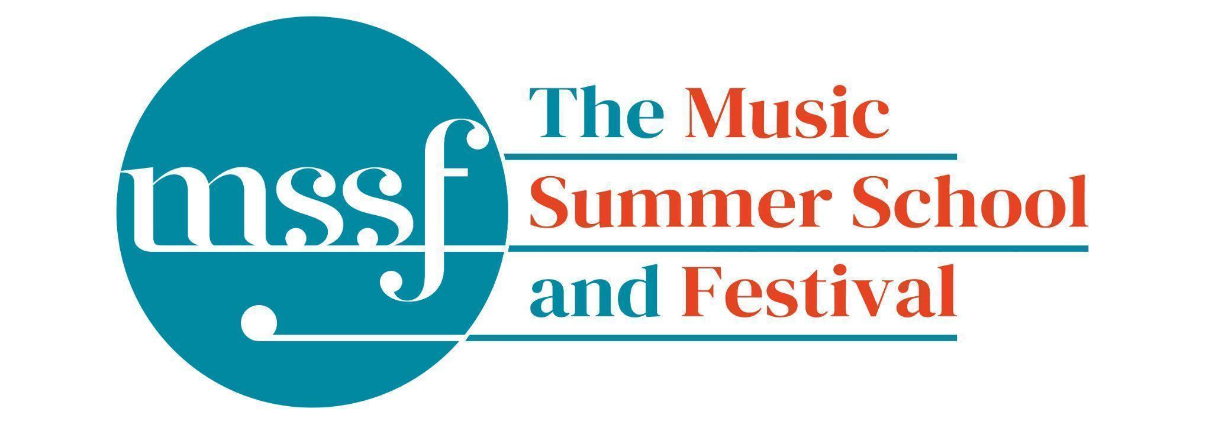
Daily Programme

Thursday 6 August 2026
Tai-Chi - Moving Meditation  With Doris Schierer | Chapel Lawn | 7.15am to 7.45am - the gentle exercise of Tai-Chi helps to improve balance and co-ordination.

Session 1 (09:00-10:30)
Choir: Rameau, Bach, Schütz, Schein & Handel  directed by Robert Hollingworth | Chapel
Orchestral Workshop  directed by Rhiannon Evans | BS5  Big School
Chamber Music  directed by Rhiannon Evans | BS4 & BS3  Big School
Advanced Baroque Chamber Music  directed by The Brook Street Band | Big School Hall & BS2  Big School
Viol Consorts  directed by Gavin Kibble | BS14  Big School
Big Band  directed by Steve Dummer | Auden Theatre Bar | Please note change of venue
Composition for violin and electronics  directed by Pierre-Alexandre Tremblay &  Darragh Morgan | B9 ‘Greatorex’  Britten Building

Morning Break (10:30 – 11:00)

Session 2 (11:00-12:30)
Vocal Ensembles – Monteverdi and Wilbye  directed by I Fagiolini | Dyson Building  (first floor)
Baroque Orchestra  directed by Steven Devine, Conor Gricmanis,  Gavin Kibble & Gail Hennessy | Big School Hall | Fasch, Telemann and Bach
Triumphans : Music for Grand Occasions,  Ceremonies and Feasts, 1520 to 1620  directed by The City Musick | Reith Building  Reith 5 | This is on the first floor. There is a lift to the left of the main entrance (choose level 1). This session is for instrumentalists only.
Voice  directed by James Gilchrist | Chapel | Please note change of venue
To Stand Up and Sing  directed by Kate Semmens | Elephant Steps  Dyson Building
Harpsichord  directed by Jane Chapman | BS1  Big School
Collaborative Piano  directed by Anna Tilbrook | Fishmongers’ Hall  Britten Building
Jazz Ensemble  directed by Derek Nash, Marc Cecil, Paul Higgs  & Trudy Kerr | Auden Theatre | Please note change of venue
Chamber Music  directed by Rhiannon Evans & The Brook Street Band | BS2, BS4 & BS5  Big School
Folk Song Writing  directed by Adam Clark & Nic Zuppardi | Reith Building  Study Room 1 | This is on the second floor. There is a lift to the left of the main entrance (choose level 3).
Composition for violin and electronics  directed by Pierre-Alexandre Tremblay  & Darragh Morgan | B9 ‘Greatorex’  Britten Building
Organ  directed by David Titterington | Little Walsingham Church

Lunch Break (12:30 – 14:00)
Friday Night’s Ceilidh Band  with Kate Adcock | Chapel | 13:00 - 13:45 Anyone who would like to play in the Ceilidh Band at 10 pm ish in the Auden Bar on Friday night please come along to learn some tunes.
Ballroom Dancing  with Doris Schierer | BS15  Big School | 13:10 - 13:40 Everyone’s welcome to drop in, no partner needed.  Learn and dance the basic moves in all the popular Ballroom and Latin American styles that look sooo easy on Strictly. Whether you're completely new to it, want a refresher or are a regular dancer keeping in practice, everyone's welcome!
Try a Viol  with Rhiannon Evans | Elephant Steps | 13:15 - 13:50 Try your hand at this fascinating historical instrument.  Everyone welcome, no experience needed.

Session 3 (14:00-15:30)
Vocal Ensembles – The Lyons Den: The Voice Unleashed  directed by The Lyons Mouth | Dyson Building  (first floor)
Song: German Lied  directed by James Gilchrist & Anna Tilbrook | Fishmongers’ Hall  Britten Building
Folk Music Ensemble  directed by Adam Clark & Nic Zuppardi | Reith Building  Study Room 1 | This is on the second floor. There is a lift to the left of the main entrance (choose level 3).
Baroque Orchestra  directed by Steven Devine, Conor Gricmanis,  Gavin Kibble & Gail Hennessy | Big School Hall | Fasch, Telemann and Bach
Jazz Ensemble  directed by Derek Nash, Marc Cecil, Paul Higgs  & Trudy Kerr | Auden Theatre | Please note change of venue
Organ  directed by David Titterington | Little Walsingham Church
Harpsichord  directed by Jane Chapman | BS1  Big School
Triumphans : Music for Grand Occasions, Ceremonies and Feasts, 1520 to 1620  directed by The City Musick | Reith Building  Reith 5 | This is a self-guided session whilst the course tutors are rehearsing for the evening concert.
To Stand Up and Sing  directed by Kate Semmens | Elephant Steps  (Dyson Building)
Jam Band  directed by Steve Dummer | BS15  Big School
Composition for violin and electronics  directed by Pierre-Alexandre Tremblay &  Darragh Morgan | B9 ‘Greatorex’  Britten Building
Chamber Music  directed by Rhiannon Evans & The Brook Street Band | BS4 & BS5  Big School

Session 4 (16:00-17:00)
Find your Voice  directed by I Fagiolini & The Lyons Mouth | Reith Building  Goff Lecture Theatre (R3) | Please note change of venue  The world is charged by Joanna Marsh
Folk Music Ensemble  directed by Adam Clark & Nic Zuppardi | Reith Building  Study Room 2 | This is on the second floor. There is a lift to the left of the main entrance (choose level 3).
Baroque Orchestra  directed by Steven Devine, Conor Gricmanis,  Gavin Kibble & Gail Hennessy | Big School Hall | Fasch, Telemann and Bach
Recorder Consorts  directed by Rhiannon Evans & Naomi Okuda Wooderson | D1.04  Dyson Building  (first floor)
Advanced Jazz Improvisation  directed by Derek Nash | Auden Theatre | Please note change of venue
Jazz A Cappella Voice  directed by Trudy Kerr | B18 & B19  Britten Building
An Introduction to Improvisation  directed by Steve Dummer | BS15  Big School
Choir Notes and Confidence  directed by Gavin Roberts | Elephant Steps  Dyson Building
Chamber Music  directed by Rhiannon Evans & The Brook Street Band | BS2, BS3 & BS4  Big School

Thursday 6 August 2026 - Concerts and Talks

17:15  CONCERT  Intesa Duo  ‘Voices of San Lazzaro’ | Fishmongers’ Hall | Celebrating their union between Armenian and Italian traditions, Intesa explores the connections between sacred and secular love, both in their pain and redemption- highlighting the Armenian story of faith, and the women’s story of misunderstanding. These stories are told through pieces selected from both traditions, which are woven together in sets through music and narrative. Intesa’s practice of self-accompaniment is inspired by figures like Francesca Caccini, Barbara Strozzi, and the Concerto delle donne, as well as the Armenian ashugh traditions of storytelling through song with the accompaniment of the kamancha.
19:30  CONCERT  The City Musick  ‘To Honour the Cittie’ | Chapel | The Waits were the official civic ensemble for the city of London and the Lord Mayor. Their heyday was in the late 16th and first half of the 17th centuries, when they could boast a highly skilled and versatile membership of multi-instrumentalists and singers who were much in demand for civic processions, celebrations, private music in tavern and household, and were the theatre band for Shakespeaare’s company, The King’s Men. This concert provides a glimpse into the busy working life of a wait, with diverse music for civic ceremony, the playhouse, dance hall, tavern , and chapel.
21:30  CONCERT  Derek Nash and the MSSF Jazz Collective  ‘Past Bedtime, Jazz gets Loose’ | Auden Theatre | The concert opens with the MSSF Jazz Choir, accompanied by a rhythm section featuring Malcolm Creese, Marc Cecil and Paul Higgs, with acclaimed saxophonist Derek Nash as featured soloist. Following the choir's performance, the Derek Nash Quintet, featuring Derek Nash, Trudy Kerr, Paul Higgs, Malcolm Creese and Marc Cecil, will take to the stage for an electrifying set, showcasing their exceptional artistry across a rich spectrum of jazz styles. Drawing inspiration from the timeless melodies of Tin Pan Alley and the Great American Songbook, alongside modern jazz classics and the infectious rhythms of bossa nova, their performance celebrates the improvisatory spirit at the heart of live jazz, honouring the rich traditions of the genre while embracing innovation.

Office Opening Hours (Dyson Building, Room D0.05)
Saturday | 8.30am - 10am | 2pm – 6.30pm
Sunday | 8.30am - 12.45pm | 1.45pm - 5.30pm
Monday - Friday | 8.45am – 12.45pm | 1.45pm - 5.30pm

Practice Rooms and Studio Booking Times:
All studios and practice rooms are open 8am – 10pm. Booking sheets for practice rooms are posted at 1.45pm daily on each practice room for the following day. Larger spaces are sometimes available for practice and can be booked with the Summer School Office Manager – please enquire in the Summer School Office in the Dyson Building (Room D0.05) for availability. These can be booked from 1.45pm for the following day (and from 8.30am on Sunday for Sunday bookings).
The instrument store room is located next door to the Summer School Office in the Dyson Building, Room D0.04.
Cafe and Bar Opening Hours: Tigs Café, situated in the Britten Building, is open from 10am to 4pm every day. The Auden Theatre Bar is open from 4pm to 11pm every day (midnight on Fridays).
Available in the Cafe - Wraps, Cakes, Light Meals - Hot and Cold Drinks - Ice Cream
Wine at dinner is available to purchase by the glass (£6.50) or bottle (£22) during dinner. Unfinished bottles can be labelled and kept in the fridge so that you can finish it off another evening.
Croquet - the croquet set is available to borrow from the Summer School Office (Dyson Building, Room D0.05) during office hours.
Swimming - The swimming pool, included in your summer school package, is open from 6.00am-8.30am and from 4pm-6pm.

