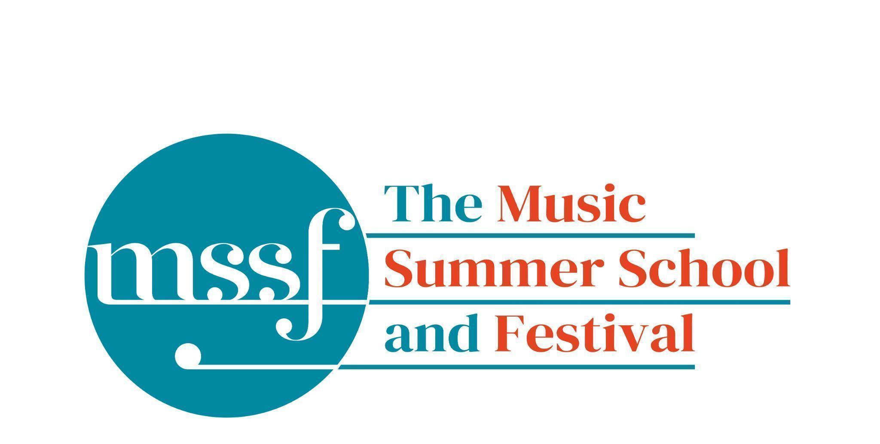

Daily Programme
Thursday 13 August 2026
Tai-Chi - Moving Meditation  With Doris Schierer | Chapel Lawn | 7.15am to 7.45am - the gentle exercise of Tai-Chi helps to improve  balance and co-ordination.

Session 1 (09:00-10:30)
Choir : Haydn’s Harmoniemesse  Britten’s Jubilate Deo and Te Deum  directed by Graham Ross | Chapel
Percussion Ensemble  directed by Ensemble Bash | B1 and B9  (Britten Building)
Light Orchestra  directed by Steve Dummer | Big School Hall | Please bring a stand
Advanced Chamber Music  directed by Wihan Quartet | Various | BS1, BS2, BS3, BS5, B10, B17, B18/19, B20, Reith 3, Fishmongers Hall
Brass Ensemble  directed by Paul Archibald & Donal Bannister | Reith Study Room 1 | This is on the 2nd floor. There is a lift at the end of the left corridor  (choose floor 3)
Chamber Music  directed by Rhiannon Evans | Various | Tallis Common Room, BS4, BS15, D104

Morning Break (10:30 – 11:00)
Session 2 (11:00-12:30)

Voice  directed by Claire Booth | Elephant Steps  (Dyson Building)
Chamber Music  directed by Rhiannon Evans, Tim Horton, Wihan Quartet | Various | BS1, BS2, BS3, BS4, BS5
Wind Band  directed by Steve Dummer | Big School Hall
Opera Ensemble  directed by Pippa Dames Longworth,  Ian Rutherford & Andrew Smith | Auden Theatre & Farfield Common Room
Piano  directed by Florian Mitrea | Fishmongers Hall
Chamber Choir: Shearing - Songs and Sonnets  Elgar - From the Bavarian Highlands  directed by Gavin Roberts | Chapel
Double Bass  directed by Levi Andreassen | BS15  (Big School)
Cello  directed by Gemma Rosefield | B18/19  (Britten Building)
Viola  directed by Rachel Robert | B20  (Britten Building)
Violin  directed by Benjamin Nabarro | B17  (Britten Building)
Tango Orchestra  directed by Mirek Salmon, Caroline Pearsall,  Daryl Kellie | Tallis Common Room | Code for Tallis is 962375

Lunch Break (12:30 – 14:00)
Ballroom Dancing  With Doris Schierer | Big School Hall  Please note change of venue | 13:10 - 13:40 Learn and dance the basic moves in all the popular Ballroom and Latin American styles that look sooo easy on Strictly. Whether you're completely new to it, want a refresher or are a regular dancer keeping in practice, everyone's welcome! No partner needed for this drop in session.
LUNCHTIME CONCERT  Julian Davis and Elizabeth Williams - pianos | Fishmongers’ Hall | Gottes Zeit ist die allerbeste Zeit BWV 106 - J.S. Bach (arr. Kurtág)  Andante in G with five variations KV 501 - Mozart  Spanish Dance from La Vida Breve - De Falla (arr. Samazeuilh)  Moto Perpetuo (2011) - Anne Cawrse (b. 1981)

Session 3 (14:00-15:30)
Voice  directed by Sarah Gabriel | D1.04  (Dyson Building)
Percussion  directed by Ensemble Bash | B1 Percussion Room & B9  (Britten Building)
Flute  Directed by Nancy Ruffer | B17  (Britten Building)
Trombone  directed by Donal Bannister | B18/19  (Britten Building)
Collaborative Piano  directed by Anna Tilbrook | Big School Hall
The Lone Voice - works for unaccompanied voice  directed by Claire Booth | Elephant Steps  (Dyson Building)
Chamber Music  directed by Rhiannon Evans,  Tim Horton & Wihan Quartet | BS2, BS3, BS5  (Big School)
Opera Ensemble  directed by Pippa Dames Longworth, Ian Rutherford & Andrew Smith | Auden Theatre and Farfield Common Room
String Ensemble  directed by Gemma Rosefield, Levi Andreasson, Benjamin Nabarro, Rachel Roberts | Reith 5  (Reith Building)
Piano  Directed by Florian Mitrea | Fishmongers Hall  (Britten Building)
Horn  directed by Benjamin Hartnell-Booth | D1.14  (Dyson Building)
Trumpet  directed by Paul Archibald | D1.17  (Dyson Building)
Bassoon  directed by Angharad Thomas | B10 - Shaw  (Britten Building)
Oboe  Directed by Adrian Wilson | B20  (Britten Building)
Clarinet  directed by Robert Plane | BS1  (Big School)
Tango Orchestra  directed by Mirek Salmon, Daryl Kellie,  Caroline Pearsall | Tallis Common Room | Code for Tallis is 962375
The Complete Saxophone Course  directed by Huw Wiggin | BS15  (Big School)

Tea Break (15:30 – 16:00)
Light Orchestra  directed by Steve Dummer | Outside Tigs Cafe | Tea Dance - from the golden age of light music, the Summer School Light Orchestra will bring to life the elegance and charm of dance music, including polkas, tangos, fox-trots and waltzes. Enjoy the music with a cup of tea, or put on your dancing shoes and strut your stuff!
Session 4 (16:00-17:00)
Pure Imagination  directed by Sarah Gabriel | Elephant Steps  (Dyson Building)
West Africa Drumming  directed by Richard Benjafield | B1, B9, B10  (Britten Building)
Classical Orchestra  directed by Graham Ross | Chapel | Please note change of venue. This session is with the soloists from the Haydn Mass. Please leave promptly after the session so that we can set up for the 5.15pm concert
Choir Notes and Confidence Workshop  directed by Gavin Roberts | D1.04  (Dyson Building)
Saxophone Ensemble  directed by Huw Wiggin | D1.07  (Dyson Building) | Please note change of venue
Tango Dance  directed by John Mason | Tallis Common Room | Code for Tallis is 962375
Opera Ensemble Orchestra and Singers  directed by Steve Dummer, with Pippa Dames Longworth, Ian Rutherford & Andrew Smith | Reith 5  (Reith Building)
Chamber Music  directed by Rhiannon Evans, Anna Tilbrook, Ensemble 360,  Nancy Ruffer | B17, B18/19, B20  BS1, BS2, BS3, BS4, BS5, BS15

Thursday 13 August 2026 - Concerts and Talks

17:15  CONCERT  Summer School Chamber Choir  Gavin Roberts - director  ‘The Poet’s Horizon’ | Chapel | George Shearing – Songs and Sonnets  Edward Elgar – Songs from the Bavarian Highlands  The Summer School Chamber Choir explores two radiant choral cycles inspired by poetry and landscape. Shearing’s Songs and Sonnets weave Shakespeare’s words into lush, jazz-inflected harmonies of irresistible warmth, while Elgar’s Songs from the Bavarian Highlands brim with rustic charm, lyrical beauty and affectionate humour. A concert of glowing textures and expressive storytelling—choral music to lift the spirit and stir the heart.
19:30  CONCERT  Summer School String Ensemble, Brass Ensemble, Saxophone Ensemble and students from the instrumental classes | Start at Fishmongers’ Hall, then progress to the Chapel with musical interludes en route. | Benjamin Britten – Simple Symphony  Arvo Pärt – Cantus in Memoriam Benjamin Britten  The Summer School String Ensemble shares the stage with the Brass Ensemble, Saxophone Ensemble and students from the instrumental classes. This promenade performance culminates with two powerful works for strings: Benjamin Britten’s playful and expressive Simple Symphony, and Arvo Pärt’s haunting Cantus in Memoriam Benjamin Britten, a moving tribute of striking simplicity and depth. Alongside these, student performances bring a rich variety of repertoire and styles.
21:30  CONCERT  Sarah Gabriel - soprano  Florian Mitrea - piano  Steve Dummer - clarinet  ‘Pure Imagination’ | Big School Hall | A herd of grand pianos grazing in a meadow, impossible beasts and talking teapots, fables, lullabies and fairy tales, fragile fragments of childhood, a tentative return to lost love, and the conjuring of magical possibilities in time to come. Sarah, Steve and Florian perform treasured music by some of their favourite composers, including Gershwin, Debussy, Nina Simone, Kurt Weill, Poulenc, Samuel Barber, and Hoagy Carmichael. Settle in with a glass of wine or perhaps an ice cream.

Office Opening Hours (Dyson Building, Room D0.05)
Saturday | 8.30am - 10am | 2pm – 6.30pm
Sunday | 8.30am - 12.45pm | 1.45pm - 5.30pm
Monday - Friday | 8.45am – 12.45pm | 1.45pm - 5.30pm

Practice Rooms and Studio Booking Times:
All studios and practice rooms are open 8am – 10pm. Booking sheets for practice rooms are posted at 1.45pm daily on each practice room for the following day. Larger spaces are sometimes available for practice and can be booked with the Summer School Office Manager – please enquire in the Summer School Office in the Dyson Building (Room D0.05) for availability. These can be booked from 1.45pm for the following day (and from 8.30am on Sunday for Sunday bookings).
The instrument store room is located next door to the Summer School Office in the Dyson Building, Room D0.04.
Cafe and Bar Opening Hours: Tigs Café, situated in the Britten Building, is open from 10am to 4pm every day. The Auden Theatre Bar is open from 4pm to 11pm every day (midnight on Fridays).
Available in the Cafe - Wraps, Cakes, Light Meals - Hot and Cold Drinks - Ice Cream
Wine at dinner is available to purchase by the glass (£6.50) or bottle (£22) during dinner. Unfinished bottles can be labelled and kept in the fridge so that you can finish it off another evening.
Croquet - the croquet set is available to borrow from the Summer School Office (Dyson Building, Room D0.05) during office hours.
Swimming - The swimming pool, included in your summer school package, is open from 6.00am-8.30am and from 4pm-6pm.

