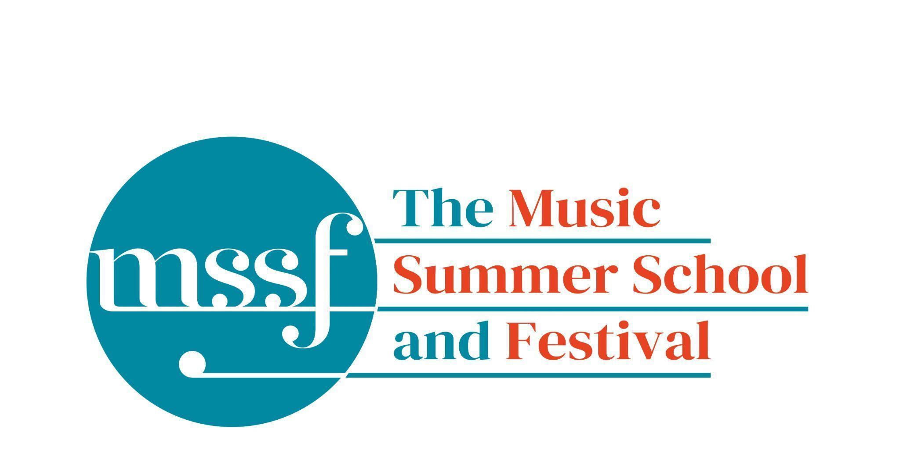

Daily Programme
Saturday 8 August 2026
Welcome to The Music Summer School and Festival 2026
15:00  CHECK IN OPENS |  | Please check in at your accommodation.  The Summer School Office, opposite the Chapel, is open from 2.00 - 6.30pm if you have any questions.
18:15 - 19:15  DINNER | Dining Room | Please have your Summer School pass with you.
19:30  CONCERT  Wihan Quartet  ‘Fire and Reflection’ | Auden Theatre | Pyotr Ilyich Tchaikovsky – String Quartet No. 3 in Eb minor, Op. 30  Antonin Dvořák – String Quartet no.13 in G major, op.106  Tchaikovsky’s deeply personal Third Quartet moves from profound grief to radiant hope, while Dvořák’s expansive Thirteenth Quartet overflows with warmth, lyricism and rhythmic vitality. Together, these masterpieces offer a compelling journey through introspection, resilience and exuberant celebration, showcasing the expressive power and richness of the string quartet.

Sunday 9 August 2026
Tai-Chi - Moving Meditation  With Doris Schierer | Chapel Lawn | 7.15am to 7.45am - the gentle exercise of Tai-Chi helps to improve balance and co-ordination.
Orientation meeting  with Richard Heason | Elephant Steps  Dyson Building | A short meeting at 8.15am to help you get your bearings.
Chamber Music  directed by Rhiannon Evans | Elephant Steps  Dyson Building | A short meeting at 8.30am for all chamber music participants.

Session 1 (09:00-10:30)
Choir : Haydn’s Harmoniemesse  Britten’s Jubilate Deo and Te Deum  directed by Graham Ross | Chapel | Gavin Roberts will be taking this rehearsal, Graham will arrive later today.  Pre-ordered music can be collected and paid for at the Summer School office
Percussion Ensemble  directed by Ensemble Bash | B1 Percussion Room  (Britten Building)
Light Orchestra  directed by Steve Dummer | Big School Hall | Please bring a stand
Advanced Chamber Music  directed by Wihan Quartet | Various | BS1, BS2, BS3, BS5, B10, B17, B18/19, B20, Reith 3, Fishmongers Hall
Brass Ensemble  directed by Paul Archibald & Donal Bannister | Reith Study Room 1 | This is on the 2nd floor. There is a lift at the end of the left corridor  (choose floor 3)
Chamber Music  directed by Rhiannon Evans | Various | Tallis Common Room, BS4, BS15, D104

Morning Break (10:30 – 11:00)

Session 2 (11:00-12:30)

Voice  directed by Claire Booth | Elephant Steps  (Dyson Building)
Chamber Music  directed by Rhiannon Evans, Tim Horton, Wihan Quartet | Various | BS1, BS2, BS3, BS4, BS5
Wind Band  directed by Steve Dummer | Big School Hall
Opera Ensemble  directed by Pippa Dames Longworth,  Ian Rutherford & Andrew Smith | Auden Theatre
Piano  directed by Florian Mitrea | Fishmongers Hall
Chamber Choir: Shearing - Songs and Sonnets  Elgar - From the Bavarian Highlands  directed by Gavin Roberts | D104  (Dyson Building) | Pre-ordered music can be collected and paid for at the Summer School office. From Monday this course will take place daily in the Chapel
Double Bass  directed by Levi Andreassen | BS15  (Big School)
Cello  directed by Gemma Rosefield | B18/19  (Britten Building)
Viola  directed by Rachel Robert | B20  (Britten Building)
Violin  directed by Benjamin Nabarro | B17  (Britten Building)
Tango Orchestra  directed by Mirek Salmon, Caroline Pearsall,  Daryl Kellie | Tallis Common Room | Code for Tallis is 962375

Lunch Break (12:30 – 14:00)
Ballroom Dancing  With Doris Schierer | BS15  Big School | 13:10 - 13:40 - Learn and dance the basic moves in all the popular Ballroom and Latin American styles that look sooo easy on Strictly. Whether you're completely new to it, want a refresher or are a regular dancer keeping in practice, everyone's welcome! No partner needed for this drop in session.

Session 3 (14:00-15:30)
Voice  directed by Sarah Gabriel | D1.04  (Dyson Building)
Percussion  directed by Ensemble Bash | B1 Percussion Room & B9  (Britten Building)
Flute  Directed by Nancy Ruffer | B17
Trombone  directed by Donal Bannister | B18/19  (Britten Building)
Collaborative Piano  directed by Anna Tilbrook | Big School Hall
The Lone Voice - works for unaccompanied voice  directed by Claire Booth | Elephant Steps  (Dyson Building)
Chamber Music  directed by Rhiannon Evans,  Tim Horton & Wihan Quartet | BS2, BS3, BS5  (Big School)
Opera Ensemble  directed by Pippa Dames Longworth, Ian Rutherford & Andrew Smith | Auden Theatre
String Ensemble  directed by Gemma Rosefield, Levi Andreasson, Benjamin Nabarro, Rachel Roberts | Reith 5  (Reith Building)
Piano  Directed by Florian Mitrea | Fishmongers Hall
Horn  directed by Benjamin Hartnell-Booth | D1.14  (Dyson Building)
Trumpet  directed by Paul Archibald | D1.17  (Dyson Building)
Bassoon & Oboe  directed by Angharad Thomas | B10 - Shaw | Adrian Wilson’s oboe class will start on Monday
Clarinet  directed by Robert Plane | BS1  (Big School)
Tango Orchestra  directed by Mirek Salmon, Daryl Kellie, Caroline Pearsall | Tallis Common Room | Code for Tallis is 962375
The Complete Saxophone Course  directed by Huw Wiggin | BS15  (Big School)

Session 4 (16:00-17:00)
Pure Imagination  directed by Sarah Gabriel | Dyson Elephant Steps
West Africa Drumming  directed by Richard Benjafield | Reith Study Room 1
Classical Orchestra  directed by Graham Ross | Big School Hall
Choir Notes and Confidence Workshop  directed by Gavin Roberts | D1.04  (Dyson Building)
Saxophone Ensemble  directed by Huw Wiggin | D1.114  (Dyson Building)
Tango Dance  directed by John Mason | Tallis Common Room | Code for Tallis is 962375
Opera Ensemble Orchestra  directed by Steve Dummer | Reith 5  (Reith Building)
Chamber Music  directed by Rhiannon Evans, Anna Tilbrook, Ensemble 360,  Nancy Ruffer | B17, B18/19, B20  BS1, BS2, BS3, BS4, BS5, BS15
Opera Ensemble  directed by Pippa Dames Longworth, Ian Rutherford, Andrew Smith | Auden Theatre

Sunday 9 August 2026 - Concerts and Talks

17:15  CONCERT  Paul Archibald - trumpet  Richard Shaw - piano  ‘Resonant Horizons’ | Fishmongers’ Hall | Anna Segal – Horizon for Trumpet and Piano  Ned Rorem – Cries and Whispers  Karen Tanaka – Silent Ocean  Anthony Plog – Sonata  A journey of colour, atmosphere, and emotional depth unfolds in this captivating programme for trumpet and piano. From the shimmering expanses of Anna Segal’s Horizon to the intimate reflections of Ned Rorem’s Cries and Whispers, each work reveals a unique voice. Karen Tanaka’s Silent Ocean evokes stillness and mystery, while Anthony Plog’s virtuosic Sonata brings brilliance and vitality. Together, these pieces explore the trumpet’s expressive range beyond fanfare, blending lyricism, drama, and contemporary sound worlds in a compelling dialogue between instruments that promises both contrast and cohesion.
19:30  CONCERT  Claire Booth - soprano  Anna Tilbrook - piano | Auden Theatre | Oliver Knussen – The Learn’d Astronomer  Franz Schubert – Die Sterne  Robert Schumann – Mondnacht  Johanna Muller Hermann – Wie eine vollmondnacht  Alban Berg – Nacht  Clara Schumann – Mein Stern  Modest Mussorgsky – Noch (Night)  Sergei Rachmaninov – V molchani nochi taynoy (In the Silence of the Secret Night)  Nicolai Rimsky-Korsakov – In the dark the Nightingale is Silent  Pyotr Il’yich Tchaikovsky – gentle stars shone for us  Gabriel Fauré – Clair de lune  Claude Debussy – Nuit d’etoiles  Rita Strohl – Roses dans la nuit  Claude Debussy – Clair de Lune  Thea Musgrave – The Man in the Moon  Elizabeth Maconchy – Sun, Moon and Stars  Benjamin Britten – At the mid hour of the night  Muriel Herbert – How beautiful is night  Ralph Vaughan Williams – The Infinite Shining Heavens  Claire Booth and Anna Tilbrook return with a celestial-inspired programme, The Infinite Shining Heavens, exploring humanity’s enduring fascination with the night sky. Embracing wonder, solitude and transcendence, the recital opens with the astronomer himself in Oliver Knussen’s reimagining of Walt Whitman’s The Learn’d Astronomer. Journeying through German, Russian, French and English song traditions, it pairs the shimmer of Fauré’s Clair de lune with its German counterpart in Schumann’s Mondnacht, culminating in Vaughan Williams’ visionary The Infinite Shining Heavens, where private emotion meets cosmic vastness.
21:30  CONCERT  Ensemble Bash  ‘Rhythm without Borders’ | Chapel | Traditional Ghanaian, arr. Afadina Atsikpa & Ensemble Bash – Siwe Bell Music  Traditional Ghanaian – xylophone music played on the Gyil  Simon Limbrick – Tunnel  Michael Blake – Let us Run Out of the Rain  Nick Hayes – Shining Through  Traditional Senegalese, arr. Paulinus Bozie & Ensemble Bash – Kumpo  Rhythm, colour and exhilarating virtuosity collide in a programme that spans continents and sound worlds. Ensemble Bash bring the vibrant pulse of Ghanaian and Senegalese traditions—featuring the luminous gyil—alongside striking contemporary works by Simon Limbrick, Michael Blake and Nick Hayes. From hypnotic bell patterns to shimmering modern textures, this is music that moves the body as much as the imagination: joyful, elemental and irresistibly alive.

Office Opening Hours (Dyson Building, Room D0.05)
Saturday | 8.30am - 10am | 2pm – 6.30pm
Sunday | 8.30am - 12.45pm | 1.45pm - 5.30pm
Monday - Friday | 8.45am – 12.45pm | 1.45pm - 5.30pm

Practice Rooms and Studio Booking Times:
All studios and practice rooms are open 8am – 10pm. Booking sheets for practice rooms are posted at 1.45pm daily on each practice room for the following day. Larger spaces are sometimes available for practice and can be booked with the Summer School Office Manager – please enquire in the Summer School Office in the Dyson Building (Room D0.05) for availability. These can be booked from 1.45pm for the following day (and from 8.30am on Sunday for Sunday bookings).
The instrument store room is located next door to the Summer School Office in the Dyson Building, Room D0.04.
Cafe and Bar Opening Hours: Tigs Café, situated in the Britten Building, is open from 10am to 4pm every day. The Auden Theatre Bar is open from 4pm to 11pm every day (midnight on Fridays).
Available in the Cafe - Wraps, Cakes, Light Meals - Hot and Cold Drinks - Ice Cream
Wine at dinner is available to purchase by the glass (£6.50) or bottle (£22) during dinner. Unfinished bottles can be labelled and kept in the fridge so that you can finish it off another evening.
Croquet - the croquet set is available to borrow from the Summer School Office (Dyson Building, Room D0.05) during office hours.
Swimming - The swimming pool, included in your summer school package, is open from 6.00am-8.30am and from 4pm-6pm.
PRE-ORDERED MUSIC for Choir and Chamber Choir will be available to collect and pay for from the Office during office opening hours, from outside the Chapel prior to the 7.30pm concert on Saturday evening, and again outside the Chapel before Sunday morning’s rehearsal.

