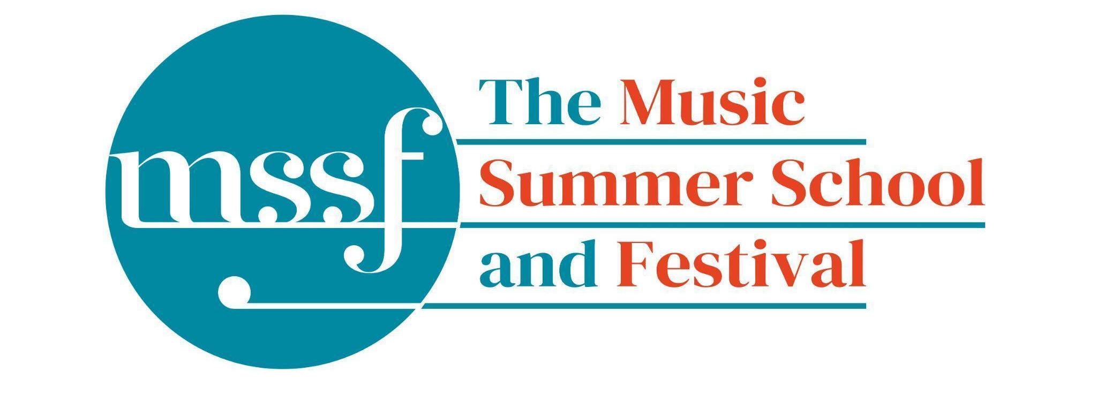
Daily Programme

Monday 3 August 2026
Tai-Chi - Moving Meditation  With Doris Schierer | Chapel Lawn | 7.15am to 7.45am - the gentle exercise of Tai-Chi helps to improve balance and co-ordination.

Session 1 (09:00-10:30)
Choir: Rameau, Bach, Schütz, Schein & Handel  directed by Robert Hollingworth | Chapel
Orchestral Workshop  directed by Rhiannon Evans | Big School Hall | Music by Muffat & Corelli
Chamber Music  directed by Rhiannon Evans | BS4 & BS5  Big School | Please see separate notice in the Dining Room, Summer School office and on Whova.
Advanced Baroque Chamber Music  directed by The Brook Street Band | BS2 & BS3  Big School | Couperin - Les Nations
Viol Consorts  directed by Gavin Kibble | BS14  Big School | Please note change of venue
Big Band  directed by Steve Dummer | Tallis Common Room | Code for Tallis is 962375
Composition for violin and electronics  directed by Pierre-Alexandre Tremblay &  Darragh Morgan | Fishmongers’ Hall  Britten Building | Please note change of venue

Morning Break (10:30 – 11:00)

Session 2 (11:00-12:30)
Vocal Ensembles – Monteverdi and Wilbye  directed by I Fagiolini | Dyson Building
Baroque Orchestra  directed by Steven Devine, Conor Gricmanis,  Gavin Kibble & Gail Hennessy | Big School Hall | Fasch, Telemann and Bach
Triumphans : Music for Grand Occasions,  Ceremonies and Feasts, 1520 to 1620  directed by The City Musick | Reith Building  Reith 5 | This is on the first floor. There is a lift to the left of the main entrance (choose level 1). This session is for instrumentalists only.
Voice  directed by James Gilchrist | Auden Theatre
To Stand Up and Sing  directed by Kate Semmens | Elephant Steps  Dyson Building
Harpsichord  directed by Jane Chapman | BS1  Big School
Collaborative Piano  directed by Anna Tilbrook | B10  Britten Building | Please note change of venue
Jazz Ensemble  directed by Derek Nash, Marc Cecil, Paul Higgs  & Trudy Kerr | Tallis Common Room | Code for Tallis is 962375
Chamber Music  directed by Rhiannon Evans & The Brook Street Band | BS2, BS4 & BS5  Big School | Please see separate notice in the Dining Room, Summer School office and on Whova.
Folk Song Writing  directed by Adam Clark & Nic Zuppardi | Reith Building  Study Room 2 | This is on the second floor. There is a lift to the left of the main entrance (choose level 3).
Composition for violin and electronics  directed by Pierre-Alexandre Tremblay  & Darragh Morgan | Fishmongers’ Hall  Britten Building
Organ  directed by David Titterington | Little Walsingham Church

Lunch Break (12:30 – 14:00)
Ballroom Dancing  With Doris Schierer | BS15  Big School | 13:10 - 13:40 Everyone’s welcome to drop in, no partner needed.  Learn and dance the basic moves in all the popular Ballroom and Latin American styles that look sooo easy on Strictly. Whether you're completely new to it, want a refresher or are a regular dancer keeping in practice, everyone's welcome!
TALK: The Flemish Harpsichord  Myth, Misunderstanding and the Magic  With Andrew Wooderson | BS5  Big School | 13:20 - 13:50 A brief exploration of the work of the Ruckers family in Antwerp and its influence on later harpsichord building and music

Session 3 (14:00-15:30)
Vocal Ensembles – The Lyons Den: The Voice Unleashed  directed by The Lyons Mouth | D1.04 to D1.16  Dyson Building  (first floor)
Song: German Lied  directed by James Gilchrist & Anna Tilbrook | Chapel | Please note change of venue
Folk Music Ensemble  directed by Adam Clark & Nic Zuppardi | Reith Building  Study Room 2 | This is on the second floor. There is a lift to the left of the main entrance (choose level 3).
Baroque Orchestra  directed by Steven Devine, Conor Gricmanis,  Gavin Kibble & Gail Hennessy | Big School Hall | Fasch, Telemann and Bach
Jazz Ensemble  directed by Derek Nash, Marc Cecil, Paul Higgs  & Trudy Kerr | Tallis Common Room | Code for Tallis is 962375
Organ  directed by David Titterington | Little Walsingham Church
Harpsichord  directed by Jane Chapman | BS1  Big School
Triumphans : Music for Grand Occasions, Ceremonies and Feasts, 1520 to 1620  directed by The City Musick | Reith Building  Reith 5 | This is on the first floor. There is a lift to the left of the main entrance (choose level 1). This session is for instrumentalists and singers.
To Stand Up and Sing  directed by Kate Semmens | Auden Theatre
Jam Band  directed by Steve Dummer | BS15  Big School
Composition for violin and electronics  directed by Pierre-Alexandre Tremblay &  Darragh Morgan | Fishmongers’ Hall  Britten Building
Chamber Music MD  directed by Rhiannon Evans & The Brook Street Band | BS4 & BS5  Big School | Please see separate notice in the Dining Room, Summer School office and on Whova.

Session 4 (16:00-17:00)
Find your Voice  directed by I Fagiolini & The Lyons Mouth | Reith Building  Goff Lecture Theatre (R3) | The world is charged by Joanna Marsh
Folk Music Ensemble  directed by Adam Clark & Nic Zuppardi | Reith Building  Study Room 2 | This is on the second floor. There is a lift to the left of the main entrance (choose level 3).
Baroque Orchestra  directed by Steven Devine, Conor Gricmanis,  Gavin Kibble & Gail Hennessy | Big School Hall | Fasch, Telemann and Bach
Recorder Consorts  directed by Rhiannon Evans & Naomi Okuda Wooderson | D1.04  Dyson Building  (first floor)
Advanced Jazz Improvisation  directed by Derek Nash | B17  Britten Building
Jazz A Cappella Voice  directed by Trudy Kerr | B18 & B19  Britten Building
An Introduction to Improvisation  directed by Steve Dummer | BS15  Big School
Choir Notes and Confidence  directed by Gavin Roberts | Elephant Steps  Dyson Building
Chamber Music  directed by Rhiannon Evans & The Brook Street Band | BS2, BS3 & BS4  Big School | Please see separate notice in the Dining Room, Summer School office and on Whova.

Monday 3rd August 2026 - Concerts and Talks

17:15  TALK  Simon Kinder | Meet at the Elephant Steps | Explore the stories of Gresham’s including its famous alumni, Britten, Auden and Berkeley, on this guided tour, led by the school’s Director of History
17:30 - 18:15  Try the Viol  Rhiannon Evans | Elephant Steps | Try your hand at this fascinating historical instrument with Rhiannon Evans.  Everyone welcome, no experience needed.
19:30  CONCERT  The Lyons Mouth  Victoria’s Secret | Chapel | Claudio Monteverdi – Ohimè, il bel viso! (extract)  Raphaella Aleotti – Vidi speciosam  Tomás Luis de Victoria – Vadam et circuibo civitatem  John Wilbye – Sweet honey-sucking bees  Clément Janequin – Le chant des oiseaux  Francis Poulenc – Par une nuit nouvelle (from Sept chansons)  Jean-Yves Daniel-Lesur – Le Cantique des cantiques No. V: Le jardin clos  Kerry Andrew – Wild Nights, Wild Nights  Claudio Monteverdi – Si ch’io vorrei morire (extract)  Carlo Gesualdo – Ecco, moriro (extract)  Tomás Luis de Victoria – Aestimatus sum  Luca Marenzio – Solo e pensoso  Kerry Andrew – Luna-cy  David Lang – Just (after Song of Songs)  Adrian Williams – Love is a babe  Gabriel Jackson – I am the rose of Sharon  Tomás Luis de Victoria – Nigra sum sed formosa  Experience love in all its colours with The Lyons Mouth as we trace the stages of falling in love—from flirtation to obsession, lust to contentment, and the devotion and despair in between. The programme weaves together some of the most sumptuous Renaissance polyphony by Victoria, luminous settings of the Biblical Song of Songs by Victoria and Aleotti, the desperate and volatile madrigals of Gesualdo and Monteverdi, and daring new works exploring passion and desire by Jean-Yves Daniel-Lesur, Kerry Andrew, Gabriel Jackson and David Lang. Sparks will fly as centuries meet, and sacred and secular collide in this intoxicating marriage of sensuous music and words.
21:30  CONCERT  Darragh Morgan – violin  Exploding Stars | Chapel | Linda Buckley – Exploding Stars  Delyth Field – Cysgodion  Arshia Samsaminia – Beyond the Autonomous Sensory Meridian Response  Pierre Alexandre Tremblay – Les lignes de dèsir  Shiva Feshareki – Zohra  Yii Kah Hoe – Imagery III  ‘New music wizard’ The Strad Magazine, Irish violinist Darragh Morgan has been described by Tom Service on BBC Radio 3 as ‘a performer who is a creative catalyst for so many new pieces and so many composers’. This atmospheric late evening programme for violin and electronics features many music written for Darragh from composers as far afield as Malaysia, Iran, Japan, and Ireland and features a work by MSSF Course Co-Director Canadian composer Pierre Alexandre Tremblay.

Office Opening Hours (Dyson Building, Room D0.05)
Saturday | 8.30am - 10am | 2pm – 6.30pm
Sunday | 8.30am - 12.45pm | 1.45pm - 5.30pm
Monday - Friday | 8.45am – 12.45pm | 1.45pm - 5.30pm

Practice Rooms and Studio Booking Times:
All studios and practice rooms are open 8am – 10pm. Booking sheets for practice rooms are posted at 1.45pm daily on each practice room for the following day. Larger spaces are sometimes available for practice and can be booked with the Summer School Office Manager – please enquire in the Summer School Office in the Dyson Building (Room D0.05) for availability. These can be booked from 1.45pm for the following day (and from 8.30am on Sunday for Sunday bookings).
The instrument store room is located next door to the Summer School Office in the Dyson Building, Room D0.04.
Cafe and Bar Opening Hours: Tigs Café, situated in the Britten Building, is open from 10am to 4pm every day. The Auden Theatre Bar is open from 4pm to 11pm every day (midnight on Fridays).
Available in the Cafe - Wraps, Cakes, Light Meals - Hot and Cold Drinks - Ice Cream
Wine at dinner is available to purchase by the glass (£6.50) or bottle (£22) during dinner. Unfinished bottles can be labelled and kept in the fridge so that you can finish it off another evening.
Croquet - the croquet set is available to borrow from the Summer School Office (Dyson Building, Room D0.05) during office hours.
Swimming - The swimming pool, included in your summer school package, is open from 6.30am-8.30am and from 4pm-6pm.

