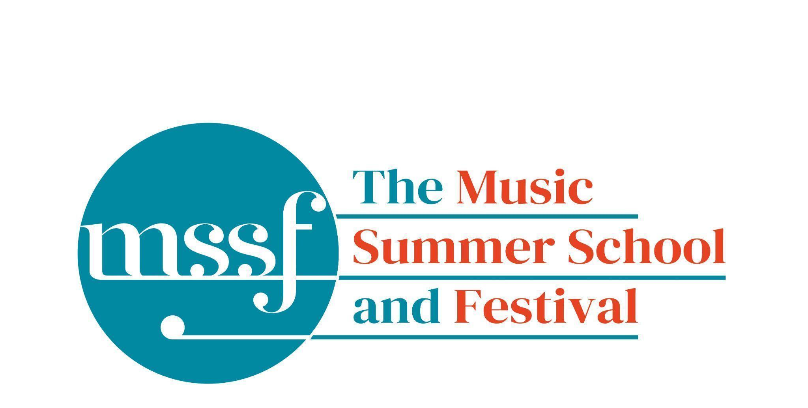

Daily Programme
Monday 10 August 2026
Tai-Chi - Moving Meditation  With Doris Schierer | Chapel Lawn | 7.15am to 7.45am - the gentle exercise of Tai-Chi helps to improve balance and co-ordination.

Session 1 (09:00-10:30)
Choir : Haydn’s Harmoniemesse  Britten’s Jubilate Deo and Te Deum  directed by Graham Ross | Chapel
Percussion Ensemble  directed by Ensemble Bash | B1 and B9  (Britten Building)
Light Orchestra  directed by Steve Dummer | Big School Hall | Please bring a stand
Advanced Chamber Music  directed by Wihan Quartet | Various | BS1, BS2, BS3, BS5, B10, B17, B18/19, B20, Reith 3, Fishmongers Hall
Brass Ensemble  directed by Paul Archibald & Donal Bannister | Reith Study Room 1 | This is on the 2nd floor. There is a lift at the end of the left corridor  (choose floor 3)
Chamber Music  directed by Rhiannon Evans | Various | Tallis Common Room, BS4, BS15, D104

Morning Break (10:30 – 11:00)
Session 2 (11:00-12:30)

Voice  directed by Claire Booth | Elephant Steps  (Dyson Building)
Chamber Music  directed by Rhiannon Evans, Tim Horton, Wihan Quartet | Various | BS1, BS2, BS3, BS4, BS5
Wind Band  directed by Steve Dummer | Big School Hall
Opera Ensemble  directed by Pippa Dames Longworth,  Ian Rutherford & Andrew Smith | Auden Theatre
Piano  directed by Florian Mitrea | Fishmongers Hall
Chamber Choir: Shearing - Songs and Sonnets  Elgar - From the Bavarian Highlands  directed by Gavin Roberts | Chapel
Double Bass  directed by Levi Andreassen | BS15  (Big School)
Cello  directed by Gemma Rosefield | B18/19  (Britten Building)
Viola  directed by Rachel Robert | B20  (Britten Building)
Violin  directed by Benjamin Nabarro | B17  (Britten Building)
Tango Orchestra  directed by Mirek Salmon, Caroline Pearsall,  Daryl Kellie | Tallis Common Room | Code for Tallis is 962375

Lunch Break (12:30 – 14:00)
Ballroom Dancing  With Doris Schierer | BS15  Big School | 13:10 - 13:40 Learn and dance the basic moves in all the popular Ballroom and Latin American styles that look sooo easy on Strictly. Whether you're completely new to it, want a refresher or are a regular dancer keeping in practice, everyone's welcome! No partner needed for this drop in session.
LUNCHTIME CONCERT:  Fiona Zarb-Adami - Soprano  Mark Zarb-Adami - Piano | Elephant Steps | 13:20 - 13:50  Sweet Chance, that led my steps abroad - Michael Head  Love’s Philosophy - Roger Quilter  Silent Noon - Ralph Vaughan Williams  Prelude No.3 in Db Major, Op.17, Waltz in Ab Major, Op.38 - Alexander Scriabin  The Man I Love (No. 3 from 7 Virtuoso Etudes after Gershwin) - Earl Wild  I can give you the Starlight - Ivor Novello  So in Love - Cole Porter  Show Me - Frederick Loewe

Session 3 (14:00-15:30)
Voice  directed by Sarah Gabriel | D1.04  (Dyson Building)
Percussion  directed by Ensemble Bash | B1 Percussion Room & B9  (Britten Building)
Flute  Directed by Nancy Ruffer | B17  (Britten Building)
Trombone  directed by Donal Bannister | B18/19  (Britten Building)
Collaborative Piano  directed by Anna Tilbrook | Big School Hall
The Lone Voice - works for unaccompanied voice  directed by Claire Booth | Elephant Steps  (Dyson Building)
Chamber Music  directed by Rhiannon Evans,  Tim Horton & Wihan Quartet | BS2, BS3, BS5  (Big School)
Opera Ensemble  directed by Pippa Dames Longworth, Ian Rutherford & Andrew Smith | Auden Theatre
String Ensemble  directed by Gemma Rosefield, Levi Andreasson, Benjamin Nabarro, Rachel Roberts | Reith 5  (Reith Building)
Piano  Directed by Florian Mitrea | Fishmongers Hall  (Britten Building)
Horn  directed by Benjamin Hartnell-Booth | D1.14  (Dyson Building)
Trumpet  directed by Paul Archibald | D1.17  (Dyson Building)
Bassoon  directed by Angharad Thomas | B10 - Shaw  (Britten Building)
Oboe  Directed by Adrian Wilson | B20  (Britten Building)
Clarinet  directed by Robert Plane | BS1  (Big School)
Tango Orchestra  directed by Mirek Salmon, Daryl Kellie, Caroline Pearsall | Tallis Common Room | Code for Tallis is 962375
The Complete Saxophone Course  directed by Huw Wiggin | BS15  (Big School)

Session 4 (16:00-17:00)
Pure Imagination  directed by Sarah Gabriel | Elephant Steps  (Dyson Building)
West Africa Drumming  directed by Richard Benjafield | B1, B9, B10  (Britten Building)
Classical Orchestra  directed by Graham Ross | Big School Hall
Choir Notes and Confidence Workshop  directed by Gavin Roberts | D1.04  (Dyson Building)
Saxophone Ensemble  directed by Huw Wiggin | D1.14  (Dyson Building)
Tango Dance  directed by John Mason | Tallis Common Room | Code for Tallis is 962375
Opera Ensemble Orchestra  directed by Steve Dummer | Reith 5  (Reith Building)
Chamber Music  directed by Rhiannon Evans, Anna Tilbrook, Ensemble 360,  Nancy Ruffer | B17, B18/19, B20  BS1, BS2, BS3, BS4, BS5, BS15
Opera Ensemble  directed by Pippa Dames Longworth, Ian Rutherford, Andrew Smith | Auden Theatre

Monday 10 August 2026 - Concerts and Talks

17:15  TALK  Simon Kinder | Meet at Elephant Steps | Explore the stories of Gresham’s including its famous alumni, Britten, Auden and Berkeley, on this guided tour, led by the school’s Director of History
17:15  CONCERT  Nancy Ruffer - flute  Richard Shaw - piano | Fishmongers’ Hall | Aaron Copland (1900-1990) - Duo for Flute and Piano  Ian Clarke (1964-present) - Hypnosis  Olivier Messiaen (1908-1992) - Le Merle Noir
19:30  CONCERT  Ensemble 360  ‘Bold Beginnings’ | Auden Theatre | Early brilliance from Beethoven and Britten  Benjamin Britten – Phantasy Quartet, Op.2  Ludwig van Beethoven – Septet in Eb major, Op.20  Inventive brilliance meets Classical charm in this sparkling programme from Ensemble 360. Britten’s youthful Phantasy Quartet unfolds in a single, compelling arc—by turns lyrical, restless and searching—while Beethoven’s effervescent Septet delights with wit, warmth and irresistible melodic flair. With its kaleidoscope of instrumental colours and convivial spirit, this concert promises music-making of vitality and finesse: intimate, uplifting and brimming with personality.
21:30  CONCERT  Pippa Dames Longworth - soprano  Ian Rutherford - baritone  Andrew Smith - piano  ‘I wonder as a I wander’ | Fishmongers’ Hall | Britten: from Gresham’s School and the Royal College of Music to Brooklyn  A Charm of Lubllabies and Appalachia  Benjamin Britten was influenced by his surroundings and his connection with writers and composers, many of whom guided, inspired and challenged him. Pippa, Ian and Andrew will explore these influences in a programme which includes well known and surprising works alongside Britten’s much loved ‘Charm of Lullabies’ and rarely performed teenage compositions written whilst he was a t Gresham’s.

Office Opening Hours (Dyson Building, Room D0.05)
Saturday | 8.30am - 10am | 2pm – 6.30pm
Sunday | 8.30am - 12.45pm | 1.45pm - 5.30pm
Monday - Friday | 8.45am – 12.45pm | 1.45pm - 5.30pm

Practice Rooms and Studio Booking Times:
All studios and practice rooms are open 8am – 10pm. Booking sheets for practice rooms are posted at 1.45pm daily on each practice room for the following day. Larger spaces are sometimes available for practice and can be booked with the Summer School Office Manager – please enquire in the Summer School Office in the Dyson Building (Room D0.05) for availability. These can be booked from 1.45pm for the following day (and from 8.30am on Sunday for Sunday bookings).
The instrument store room is located next door to the Summer School Office in the Dyson Building, Room D0.04.
Cafe and Bar Opening Hours: Tigs Café, situated in the Britten Building, is open from 10am to 4pm every day. The Auden Theatre Bar is open from 4pm to 11pm every day (midnight on Fridays).
Available in the Cafe - Wraps, Cakes, Light Meals - Hot and Cold Drinks - Ice Cream
Wine at dinner is available to purchase by the glass (£6.50) or bottle (£22) during dinner. Unfinished bottles can be labelled and kept in the fridge so that you can finish it off another evening.
Croquet - the croquet set is available to borrow from the Summer School Office (Dyson Building, Room D0.05) during office hours.
Swimming - The swimming pool, included in your summer school package, is open from 6.00am-8.30am and from 4pm-6pm.

