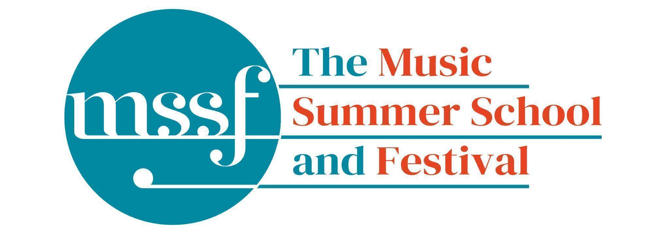
Daily Programme

Friday 7 August 2026

Tai-Chi - Moving Meditation  With Doris Schierer | Chapel Lawn | 7.15am to 7.45am - the gentle exercise of Tai-Chi helps to improve balance and co-ordination.

Session 1 (09:00-10:30)
Summer School Choir & Baroque Orchestra  Rameau, Bach, Schütz, Schein & Handel  directed by Robert Hollingworth | Chapel | Choir - please meet at 8.45 on the Chapel Lawn for a warm-up  Orchestra - please be seated for 9.00  9 - 10.45 Choir and Orchestra  10.45 - 11.00 Break  11 - 12.30 - Orchestra and soloists
Orchestral Workshop  directed by Rhiannon Evans | BS5  Big School
Chamber Music  directed by Rhiannon Evans | BS4 & BS3  Big School
Advanced Baroque Chamber Music  directed by The Brook Street Band | Big School Hall & BS2 Big School
Viol Consorts  directed by Gavin Kibble | BS14  Big School
Big Band  directed by Steve Dummer | Auden Theatre Bar
Composition for violin and electronics  directed by Pierre-Alexandre Tremblay &  Darragh Morgan | B9 ‘Greatorex’  Britten Building

Morning Break (10:30 – 11:00)

Session 2 (11:00-12:30)
Vocal Ensembles – Monteverdi and Wilbye  directed by I Fagiolini | Big School Hall | 11.00 Run through in normal breakout rooms and then meet in Big School Hall  11.30 - 12.30 An informal performance - everyone welcome!  (Victoria at the end)
Triumphans : Music for Grand Occasions,  Ceremonies and Feasts, 1520 to 1620  directed by The City Musick | Reith Building  Reith 5 | This is on the first floor. There is a lift to the left of the main entrance (choose level 1). This session is for instrumentalists only.
Voice  directed by James Gilchrist | Auden Theatre | Please note change of venue
To Stand Up and Sing  directed by Kate Semmens | Elephant Steps  Dyson Building | An informal performance - everyone welcome!
Harpsichord  directed by Jane Chapman | BS1  Big School
Collaborative Piano  directed by Anna Tilbrook | Fishmongers’ Hall  Britten Building
Jazz Ensemble  directed by Derek Nash, Marc Cecil, Paul Higgs  & Trudy Kerr | Tallis Common Room | Please note change of venue.  Code for Tallis is 962375
Chamber Music  directed by Rhiannon Evans & The Brook Street Band | BS2, BS4 & BS5  Big School
Folk Song Writing  directed by Adam Clark & Nic Zuppardi | Reith Building  Study Room 1 | This is on the second floor. There is a lift to the left of the main entrance (choose level 3).
Composition for violin and electronics  directed by Pierre-Alexandre Tremblay  & Darragh Morgan | B9 ‘Greatorex’  Britten Building
Organ  directed by David Titterington | Little Walsingham Church

Lunch Break (12:30 – 14:00)
Ballroom Dancing  with Doris Schierer | BS15  Big School | 13:10 - 13:40 Everyone’s welcome to drop in, no partner needed.  Learn and dance the basic moves in all the popular Ballroom and Latin American styles that look sooo easy on Strictly. Whether you're completely new to it, want a refresher or are a regular dancer keeping in practice, everyone's welcome!
Chamber Music Showcase  with Rhiannon Evans | Elephant Steps  (Dyson Building) | 13:15 An informal performance - everyone welcome!

Session 3 (14:00-15:30)
Vocal Ensembles – The Lyons Den: The Voice Unleashed  directed by The Lyons Mouth | Elephant Steps  (Dyson Building) | Meet at Elephant Steps usual time.  15:00 - 15:30 An informal sharing - everyone welcome!
Song: German Lied  directed by James Gilchrist & Anna Tilbrook | Fishmongers’ Hall  Britten Building
Folk Music Ensemble  directed by Adam Clark & Nic Zuppardi | Reith Building  Study Room 1 | This is on the second floor. There is a lift to the left of the main entrance (choose level 3).
Jazz Ensemble  directed by Derek Nash, Marc Cecil, Paul Higgs  & Trudy Kerr | Tallis Common Room | Please note change of venue.  Code for Tallis is 962375
Organ  directed by David Titterington | Little Walsingham Church
Harpsichord  directed by Jane Chapman | BS1  Big School
Triumphans : Music for Grand Occasions, Ceremonies and Feasts, 1520 to 1620  directed by The City Musick | Big School Hall | Please note change of venue.  There will be an informal performance from 3.00 - 3.30pm. Everyone welcome!
To Stand Up and Sing  directed by Kate Semmens | Auden Theatre | An informal performance - everyone welcome!
Jam Band  directed by Steve Dummer | B18/19 | Please note change of venue
Composition for violin and electronics  directed by Pierre-Alexandre Tremblay &  Darragh Morgan | B9 ‘Greatorex’  Britten Building | 2.30 - 3.00pm An informal performance of new works created during the week - everyone welcome!
Chamber Music  directed by Rhiannon Evans & The Brook Street Band | BS4 & BS5  Big School

Session 4 (16:00-17:00)
Find your Voice  directed by I Fagiolini & The Lyons Mouth | Big School Hall | Meet at 4.00  4.15 - 4.30 An informal performance of The world is charged by Joanna Marsh.  Everyone welcome!
Folk Music Ensemble and Writing | Auden Theatre Bar | An informal performance from participants of the Folk Music courses. Everyone welcome!
Recorder Consorts  directed by Rhiannon Evans & Naomi Okuda Wooderson | D1.04  Dyson Building  (first floor)
Advanced Jazz Improvisation  directed by Derek Nash | Tallis Common Room | Please note change of venue.  Code for Tallis is 962375
Jazz A Cappella Voice  directed by Trudy Kerr | B18 & B19  Britten Building
An Introduction to Improvisation  directed by Steve Dummer | BS15  Big School
Chamber Music  directed by Rhiannon Evans & The Brook Street Band | BS2, BS3 & BS4  Big School

Summer School Choir: Schutz and Schein  with Robert Hollingworth | Fishmongers Hall | 18:50 - 19:10 Rehearsal of the Schutz and Schein

Friday 7 August 2026 - Concerts and Talks

17:15  CONCERT  Showcase Concert | Chapel | The Showcase Concert celebrates the richness and diversity of our courses in a vibrant, inspiring performance. Featuring students from harpsichord, organ, voice and lieder, collaborative piano, and chamber music, this concert brings together a wide spectrum of repertoire and styles. From intimate some to intricate ensemble works, each performance reflects a week of dedicated study and artistic growth. The showcase offers a unique opportunity to experience emerging musicians in a supportive, creative environment, sharing their achievements with warmth, skill, and expressive flair.
19:30  CONCERT  Summer School Choir  Baroque Orchestra  Director - Robert Hollingworth | Chapel | Jean-Philippe Rameau – In Convertendo  Johann Sebastian Bach – ‘Kyrie’ and ‘Gloria’ from Lutheran Mass in F major, BWV233  Heinrich Schütz – Die Himmel erzählen  Johann Hermann Schein – Da Jakob vollendet hatte  Georg Frideric Handel – Ode on the Birthday of Queen Anne  The Summer School Choir and Baroque Orchestra explore a dazzling tapestry of Baroque splendour. From Rameau’s dramatic In Convertendo to Bach’s radiant Kyrie and Gloria, via the expressive brilliance of Schütz and Schein, the programme culminates in Handel’s jubilant Ode on the Birthday of Queen Anne. Vibrant period colours, rhythmic vitality and choral grandeur come together in music of celebration and transcendence.
After the concert…  music and dancing | Auden Theatre Bar | An end of week celebration featuring Jam Band with Steve Dummer, tunes from the Friday Night Ceilidh Band and Adam Clark calling some dances.

Saturday 8 August 2026
A coach will leave Greshams’ main carpark at 8.45am to get to Sheringham Station for the 9.37am train to Norwich.
Oakeley’s, Queens and Lawns residents will be picked up at their accommodation at 8.40pm.
Please leave your keys with your houseparent when you check out.
Safe travels and see you next year 😉🎵
Help keep the music alive
If your time at The Music Summer School & Festival has inspired, challenged or enriched you, we hope you’ll consider helping others experience it too. By becoming a monthly support of The Summer School Foundation, you’ll provide the steady reliable income that helps us plan ahead, offer bursaries, bring world-class artists to Norfolk, and ensure that the Summer School continues to thrive for generations to come.

If you are able, we’d love you to consider a regular gift of £15 per month. If you’re a UK taxpayer, adding Gift Aid increases the value of your donation at no extra cost to you. Of course, any monthly amount makes a real difference and is deeply appreciated.
Scan the QR code or visit the link below to set up your monthly donation
www.mssf.org.uk/support-us/
Thank you for helping secure the future of The Music Summer School & Festival;

Office Opening Hours (Dyson Building, Room D0.05)
Saturday | 8.30am - 10am | 2pm – 6.30pm
Sunday | 8.30am - 12.45pm | 1.45pm - 5.30pm
Monday - Friday | 8.45am – 12.45pm | 1.45pm - 5.30pm

Practice Rooms and Studio Booking Times:
All studios and practice rooms are open 8am – 10pm. Booking sheets for practice rooms are posted at 1.45pm daily on each practice room for the following day. Larger spaces are sometimes available for practice and can be booked with the Summer School Office Manager – please enquire in the Summer School Office in the Dyson Building (Room D0.05) for availability. These can be booked from 1.45pm for the following day (and from 8.30am on Sunday for Sunday bookings).
The instrument store room is located next door to the Summer School Office in the Dyson Building, Room D0.04.
Cafe and Bar Opening Hours: Tigs Café, situated in the Britten Building, is open from 10am to 4pm every day. The Auden Theatre Bar is open from 4pm to 11pm every day (midnight on Fridays).
Available in the Cafe - Wraps, Cakes, Light Meals - Hot and Cold Drinks - Ice Cream
Wine at dinner is available to purchase by the glass (£6.50) or bottle (£22) during dinner. Unfinished bottles can be labelled and kept in the fridge so that you can finish it off another evening.
Croquet - the croquet set is available to borrow from the Summer School Office (Dyson Building, Room D0.05) during office hours.
Swimming - The swimming pool, included in your summer school package, is open from 6.00am-8.30am and from 4pm-6pm.

