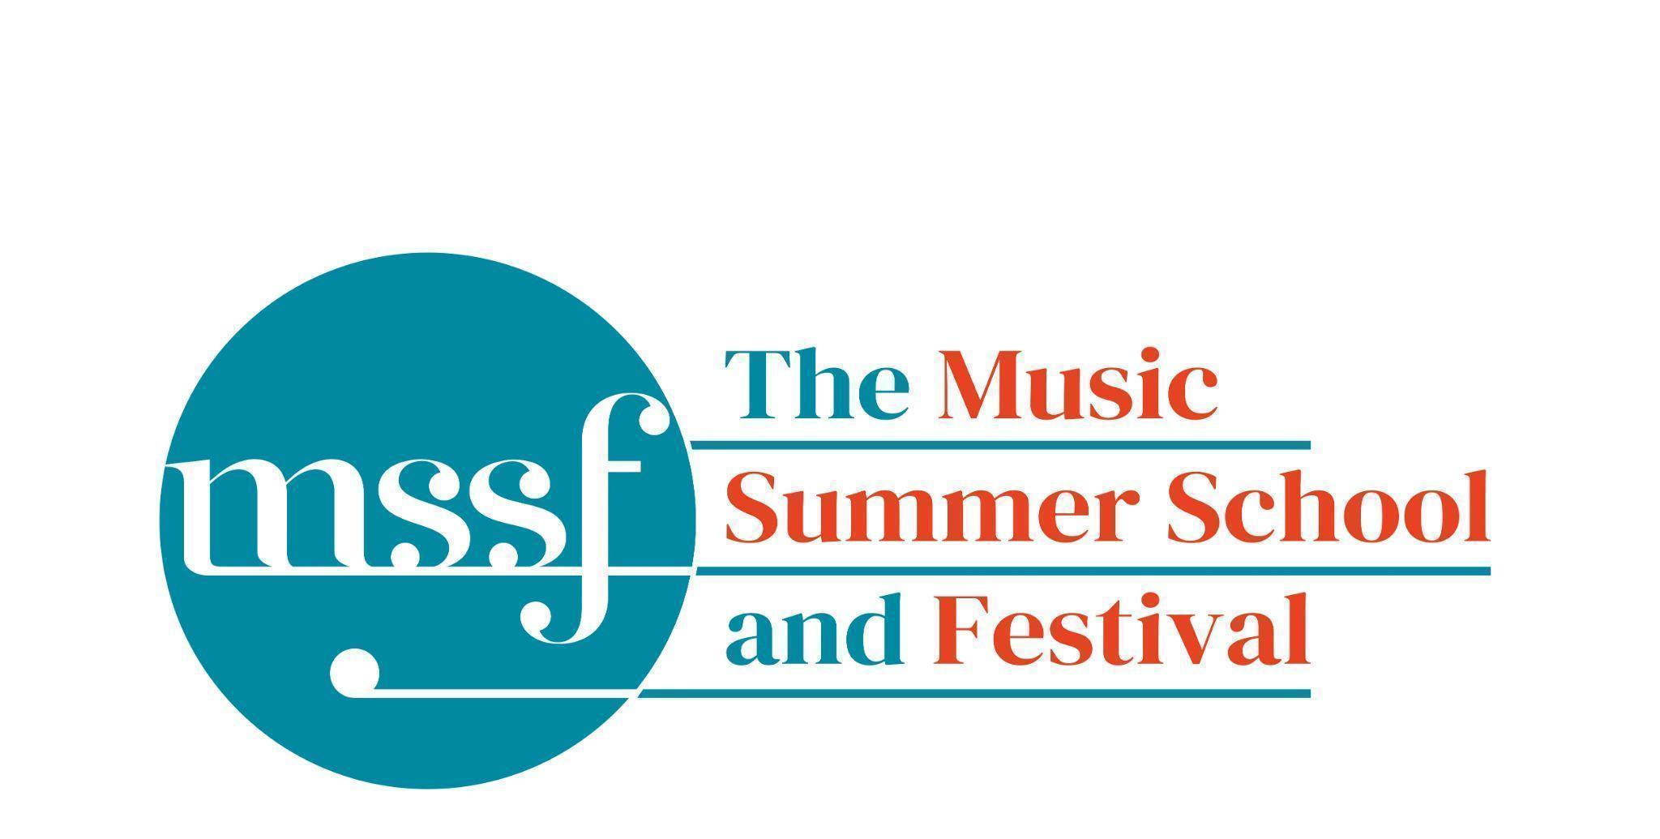

Daily Programme
Friday 14 August 2026
Tai-Chi - Moving Meditation  With Doris Schierer | Chapel Lawn | 7.15am to 7.45am - the gentle exercise of Tai-Chi helps to improve  balance and co-ordination.

Session 1 (09:00-10:30)
Choir and Orchestra :  Haydn’s Harmoniemesse  Britten’s Jubilate Deo and Te Deum  directed by Graham Ross | Chapel | Please arrive at 8.45am to take your seats for a prompt start at 9.00am.
Percussion Ensemble  directed by Ensemble Bash | B1 and B9  (Britten Building)
Light Orchestra  directed by Steve Dummer | Big School Hall | Bring a stand.
Advanced Chamber Music  directed by Wihan Quartet | Various | BS1, BS2, BS3, BS5, B10, B17, B18/19, B20, Reith 3, Fishmongers Hall
Brass Ensemble  directed by Paul Archibald & Donal Bannister | Reith Study Room 1 | This is on the 2nd floor. There is a lift at the end of the left corridor  (choose floor 3)
Chamber Music  directed by Rhiannon Evans | Various | Tallis Common Room, BS4, BS15, D104
Morning Break (10:30 – 11:00)
Session 2 (11:00-12:30)

Voice  directed by Claire Booth | Elephant Steps  (Dyson Building)
Chamber Music  directed by Rhiannon Evans, Tim Horton, Wihan Quartet | Various | BS1, BS2, BS3, BS4, BS5
Wind Band  directed by Steve Dummer | Theatre in the Woods | Please note change of venue
Opera Ensemble  directed by Pippa Dames Longworth, Ian Rutherford & Andrew Smith | Auden Theatre
Piano  directed by Florian Mitrea | Fishmongers Hall
Choir - extra support for those who would like it  directed by Gavin Roberts | Chapel
Double Bass  directed by Levi Andreassen | BS15  (Big School)
Cello  directed by Gemma Rosefield | B18/19  (Britten Building)
Viola  directed by Rachel Robert | B20  (Britten Building)
Violin  directed by Benjamin Nabarro | B17  (Britten Building)
Tango Orchestra  directed by Mirek Salmon, Caroline Pearsall,  Daryl Kellie | Tallis Common Room | Code for Tallis is 962375

Lunch Break (12:30 – 13:30)
Ballroom Dancing  With Doris Schierer | Big School Hall | 13:20 - 13:50 Learn and dance the basic moves in all the popular Ballroom and Latin American styles that look sooo easy on Strictly. Whether you're completely new to it, want a refresher or are a regular dancer keeping in practice, everyone's welcome! No partner needed for this drop in session.
LUNCHTIME CONCERT | Elephant Steps  (Dyson Building) | 13:20 - 13:50 A programme of pieces prepared during the week from the from the wind and brass classes including works by Telemann and Mel Bonis

Session 3 (14:00 - 15:30)

Voice  directed by Sarah Gabriel | D1.04  (Dyson Building)
Percussion  directed by Ensemble Bash | B1 Percussion Room & B9  (Britten Building)
Flute  Directed by Nancy Ruffer | B17  (Britten Building)
Trombone  directed by Donal Bannister | B18/19  (Britten Building)
Collaborative Piano  directed by Anna Tilbrook | Big School Hall
The Lone Voice - works for unaccompanied voice  directed by Claire Booth | Elephant Steps  (Dyson Building)
Chamber Music  directed by Rhiannon Evans,  Tim Horton & Wihan Quartet | BS2, BS3, BS5  (Big School)
String Ensemble  directed by Gemma Rosefield, Levi Andreasson, Benjamin Nabarro, Rachel Roberts | Reith 5  (Reith Building)
Opera Ensemble  directed by Pippa Dames Longworth,  Ian Rutherford & Andrew Smith | Auden Theatre
Piano  Directed by Florian Mitrea | Fishmongers Hall  (Britten Building)
Horn  directed by Benjamin Hartnell-Booth | D1.14  (Dyson Building)
Trumpet  directed by Paul Archibald | D1.17  (Dyson Building)
Bassoon  directed by Angharad Thomas | B10 - Shaw  (Britten Building)
Oboe  Directed by Adrian Wilson | B20  (Britten Building)
Clarinet  directed by Robert Plane | BS1  (Big School)
Tango Orchestra  directed by Mirek Salmon, Daryl Kellie,  Caroline Pearsall | Tallis Common Room | Code for Tallis is 962375
The Complete Saxophone Course  directed by Huw Wiggin | BS15  (Big School)

Session 4 (16:00-17:00)

Pure Imagination and Voice Class  directed by Sarah Gabriel | Elephant Steps  (Dyson Building) | A sharing of favourite songs from the week. Everyone welcome!
West Africa Drumming  directed by Richard Benjafield | B1, B9, B10  (Britten Building)
Saxophone Ensemble  directed by Huw Wiggin | D1.07  (Dyson Building)
Tango Dance  directed by John Mason | Tallis Common Room | Code for Tallis is 962375
Chamber Music  directed by Rhiannon Evans, Anna Tilbrook, Ensemble 360,  Nancy Ruffer | B17, B18/19, B20  BS1, BS2, BS3, BS4, BS5, BS15
Opera Ensemble and Orchestra  directed by Steve Dummer, Pippa Dames Longworth, Ian Rutherford, Andrew Smith | Auden Theatre | The Dress Rehearsal!
Piano Class  directed by Florian Mitrea | Fishmongers’ Hall | Everyone Welcome!

Friday 14 August 2026 - Concerts and Talks
17:15  CONCERT  Wind Band  ‘Painted Skies’ | Meet on Chapel Lawn and process to  Theatre in the Woods | Dances and Radiant Landscapes  Benjamin Britten - The Courtly Dances from ‘Gloriana’  David Bedford - Sun Paints Rainbows on the Vast Waves  The Summer School Wind Band presents a programme of colour, pageantry and imagination. Britten’s Courtly Dances from Gloriana sparkle with Renaissance elegance and rhythmic vitality, while David Bedford’s Sun Paints Rainbows on the Vast Waves unfolds in luminous textures and radiant sonic landscapes. The Theatre in the Woods will resound with brilliance, warmth and thrilling ensemble energy in a concert that celebrates the rich expressive power of the modern wind band.  We have been advised of an increased risk of falling tree branches due to the extremely dry weather - please keep to the marked paths on the route to and from the Theatre in the Woods.
19:30  CONCERT  Summer School Choir and Classical Orchestra  Grace Hope-Gill – soprano  Miro Treharne – mezzo-soprano  Joseph Hancock – tenor  Alex Bower-Brown – bass  Graham Ross – director | Chapel | Benjamin Britten – Jubilate Deo  Benjamin Britten – Te Deum in C  Joseph Haydn – Harmoniemesse, Hob. XXII:14  The Summer School Choir and Classical Orchestra unite for a programme of radiant praise and grandeur. Britten’s Jubilate Deo and Te Deum in C shimmer with clarity, vitality and luminous choral writing, while Haydn’s magnificent Harmoniemesse crowns the evening with Classical brilliance, festive colour and joyful energy. An uplifting celebration of voice and orchestra in music of splendour and spirit.
21:30  CONCERT  Il dissoluto punito  Summer School Opera Ensemble  Summer School Opera Orchestra  Steve Dummer – Conductor  Pippa Dames Longworth, Ian Rutherford & Andrew Smith – directors | Auden Theatre | Wolfgang Amadeus Mozart – excerpts from ‘Mitridate, re di Ponto’ and ‘Don Giovanni’  A week of creativity culminates in this vibrant staging of excerpts from operas by Wolfgang Amadeus Mozart. Come and see the drama, wit, and intensity of Mozart’s masterpieces come vividly to life. Expect a lively, engaging interpretation full of energy, character, and theatrical flair.
After the 21:30 concert  Milonga! | Auden Theatre Bar | Mirek, Caroline, Daryll and the Tango orquestra play tunes learnt during the week for a brilliant end of week celebration.

Saturday 15 August 2026
A coach will leave Greshams’ main carpark at 8.45am to get to Sheringham Station for the 9.37am train to Norwich.
Oakeley’s, Queens and Lawns residents will be picked up at their accommodation at 8.40pm.
Please leave your keys with your houseparent when you check out.
Safe travels and see you next year!
Help keep the music alive
If your time at The Music Summer School & Festival has inspired, challenged or enriched you, we hope you’ll consider helping others experience it too. By becoming a monthly support of The Summer School Foundation, you’ll provide the steady reliable income that helps us plan ahead, offer bursaries, bring world-class artists to Norfolk, and ensure that the Summer School continues to thrive for generations to come.

If you are able, we’d love you to consider a regular gift of £15 per month. If you’re a UK taxpayer, adding Gift Aid increases the value of your donation at no extra cost to you. Of course, any monthly amount makes a real difference and is deeply appreciated.
Scan the QR code or visit the link below to set up your monthly donation
www.mssf.org.uk/support-us/
Thank you for helping secure the future of The Music Summer School & Festival.

