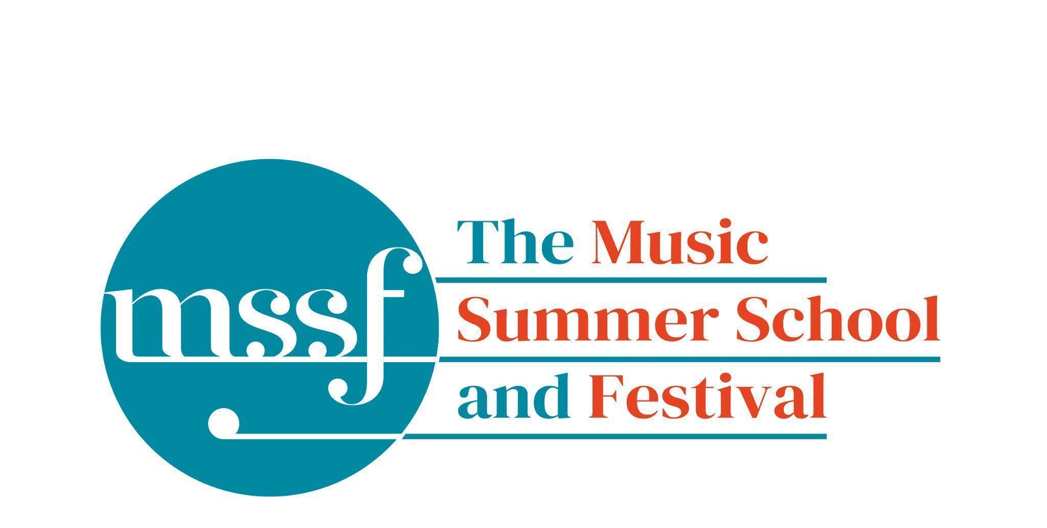

Daily Programme
Thursday 7th August 2025

Tai-Chi - Moving Meditation  With Doris Schierer | Chapel Lawn | 7.15am to 7.45am - the gentle exercise of Tai-Chi helps to improve balance and co-ordination.

Session 1 (09:00-10:30)
Choir : Handel - Israel in Egypt  directed by Andrew Griffiths | Chapel
Orchestral Workshop  Directed by Rhiannon Evans | D117  Dyson Building
Chamber Music  directed by Rhiannon Evans | Various | B9 (grand piano), BS1 (harpsichord @ 440), D104, D116

Morning Break (10:30 – 11:00)

Session 2 (11:00-12:30)

Organ  directed by David Titterington | Little Walsingham Church
Vocal Ensembles – The Golden Renaissance  directed by Stile Antico | Various | Please meet at your allocated rooms
Baroque Orchestra  directed by Steven Devine and Andrew Griffiths | Big School Hall
Connections : Musical Pathways in Renaissance Europe  directed by The City Musick | Reith Building  New Hall | This is on the second floor.
Voice  directed by Mary Nelson | Elephant Steps
To Stand Up and Sing  directed by Kate Semmens | Britten Building  B9 ‘Greatorex’
Harpsichord  directed by Marco Mencoboni | Big School  BS2
Collaborative Piano  directed by Anna Tilbrook | Britten Building  Fishmongers’ Hall
Messiaen’s 20 and the twentieth century  directed by Rolf Hind | Auden Theatre | This is just beyond the cafe.
Chamber Music  directed by Rhiannon Evans & The Brook Street Band | Various | Britten Building B18, BS1, D104, D117

Lunch Break (12:30 – 14:00)

13:10 - 13:55  directed by Kate Adcock | BS4 | Ceilidh rehearsal for all who would like to play in the band on Friday night 9.30pm
13:15 - 13:50  Try a Viol  directed by Rhiannon Evans | D104 | Try your hand at this fascinating historical instrument with Rhiannon Evans.  For those who signed up and any spectators.

Session 3 (14:00-15:30)
Voices of the Golden Age  directed by Cantoría | Reith Hall  Reith Building | This is on the first floor.
Song  directed by Mary Nelson & Anna Tilbrook | Elephant Steps
Baroque Orchestra  directed by Steven Devine and Andrew Griffiths | Big School Hall | For orchestra and soloists for Israel in Egypt
To Stand Up and Sing  directed by Kate Semmens | Auden Theatre
Harpsichord  directed by Marco Mencoboni | Big School  BS2
Organ  directed by David Titterington | Little Walsingham Church
Jam Band  directed by Steve Dummer | Big School  BS4
Composition : Making a living as a composer  directed by Stephen Montague | Britten Building  B10 ‘Shaw’
Writing for the Piano  directed by Rolf Hind | Fishmongers’ Hall
Chamber Music  directed by Rhiannon Evans & The Brook Street Band | Various | BS1, D104, D105, D106, D116, D117

Session 4 (16:00-17:00)

Sing with Stile – ‘The Italian Job: from Palestrina to Monteverdi’  directed by Stile Antico | Fishmongers’ Hall | Please note change of venue
Tenebrae: Sacred Music from the Spanish Golden Age  directed by Cantoría | Big School 4
Chamber Music  directed by Rhiannon Evans | Various | BS1, D104, D116, D117, Farfield Common Rm
An Introduction to Improvisation  directed by Steve Dummer | Britten Building  B9 ‘Greatorex’

Thursday 7th August 2025

Concerts and Talks
17:15  CONCERT  Toccami l’Anima  Marco Mencoboni - harpsichord | Big School Hall | Marcantonio Cavazzoni – Madame vous avez mon coeur  Giovanni Maria Trabaci – Durezze e ligature & Consonanze stravaganti  Johann Jacob Froberger – Tombeau sur la mort de Monsieur Blancrocher  Johann Adam Reincken – Suite No. 4 in C Major  Louis Couperin – Suite in A Minor  Jean-François Dandrieu – La Gemissante  Johann Sebastian Bach – Aria variata alla maniera italiana BWV 989
19:30  CONCERT  The Prince and the Piper  The City Musick | Chapel | Music in German Court and City 1520-1620  This concert bursts with the joyous sounds of German court and town bands in the long sixteenth century. The versatile players of The City Musick display the varied ways civic and court musicians adopted and adapted vocal polyphony for mixed ensembles of shawms, trombones, cornetts, dulcians, crumhorns, recorders, organs and regals. Repertoire comes from choir and dance books, prints and manuscripts, including the works of some of the titans of renaissance European music; from Ludwig Senfl and Paul Hofhaimer to Johann Hermann Schein, Samuel Scheidt, and Michael Praetorius.
21:30  CONCERT  David Titterington - organ | Church of St Mary and All Saints,Walsingham  Please add your name to the sign-up sheet if you would like to go in the minibus | Johann Sebastian Bach (1685 – 1750)  Fantasia in C minor BWV 562  Schmücke dich, o liebe Seele BWV 654  Herr Jesu Christ , dich zu uns wend BWV 655  O Lamm Gottes unschuldig BWV 656  Nun komm, der Heiden Heiland BWV 659  Allein Gott in der Höh sei Ehr BWV 662  Passacaglia in C minor BWV 582

Office Opening Hours (Dyson Building, Room D05):
Saturday | 8.30am - 10am | 2pm – 6.30pm
Sunday | 8.30am - 12.45pm | 1.45pm - 5.30pm
Monday - Friday | 9am – 12.45pm | 1.45pm - 5.30pm
Practice Rooms and Studio Booking Times:
All studios and practice rooms are open 8am – 10pm.
Booking sheets for practice rooms are posted at 1.45pm daily on each practice room for the following day. On Sundays the sheets will be posted at 8.30am for that day. Larger spaces are sometimes available for practice and can be booked with the Summer School Office Manager – please enquire in the Summer School Office in the Dyson Building (Room D0.05) for availability. These can be booked from 1.45pm for the following day (and from 8.30am on Sunday for Sunday bookings).
The instrument store room is located next door to the Summer School Office in the Dyson Building, Room D04.
Cafe and Bar Opening Hours: Tigs Café, situated in the Britten Building, is open from 10am to 4pm every day. The Auden Theatre Bar is open from 4pm to 11pm every day (midnight on Fridays).
Available in the Cafe - Wraps, Cakes, Light Meals - Hot and Cold Drinks - Ice Cream
Wine at dinner is available to purchase by the glass (£6) or bottle (£20) during dinner. Unfinished bottles can be labelled and kept in the fridge so that you can finish it off another evening.
Croquet - the croquet set is available to borrow from the Summer School Office (Dyson Building, Room D05) during office hours.
Swimming - The swimming pool, included in your summer school package, is open from 6.30am-8.30am and from 4pm-6pm.
Alexander Technique - Jonathon Heather is available for 1:1 and group sessions of Alexander Technique ( this is included as part of your summer school package), please book direct with Jonathon Heather in Room D118 in the Dyson Building.

