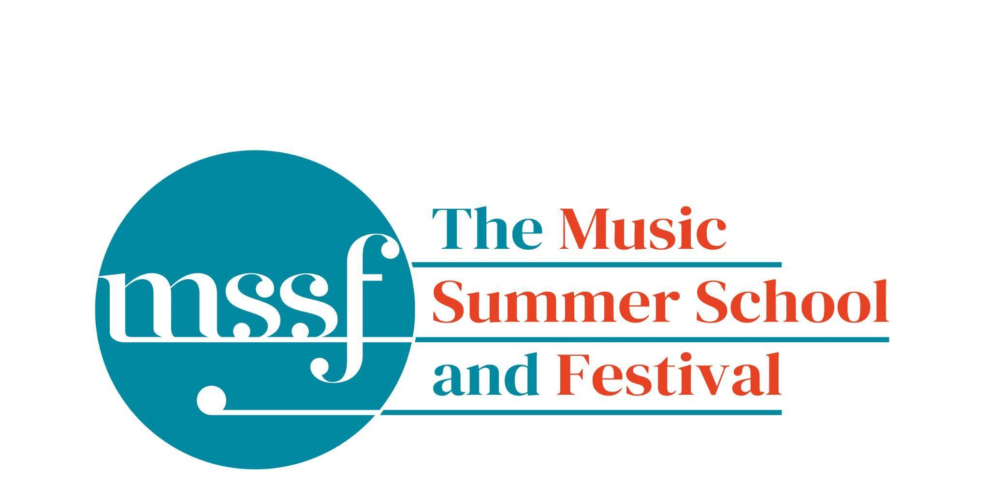

Daily Programme
Saturday 2 August 2025
Welcome to The Music Summer School and Festival 2025

19:30  CONCERT  Kitchen Conversations  The Brook Street Band | Chapel | Kitchen Conversations – a rich baroque diet to nourish mind and soul  Are you hungry? Join us in our imagined ‘kitchen’ to prepare and cook dinner for friends; there’ll be free-flowing food and wine* leading to deep conversations, mystery ingredients providing sustenance and spice, a rich baroque diet to nourish mind and soul.  *NB You’ll have to imagine that bit!  The kitchen is the heart of the home. It was hidden away in Handel’s time but no less lacking in drama and passion, servants and cooks working hard to ensure a smooth-running household. Today’s kitchens are positioned centre-stage, shared spaces for preparation, eating and drinking. Convivial food, free-flowing wine … some juicy gossip… perfect ingredients for an enticing, entertaining, thought-provoking evening.  Musical ingredients from: Telemann, Handel, JS Bach, CPE Bach, Rameau, Purcell, Errollyn Wallen.
Sunday 3 August 2025

Tai-Chi - Moving Meditation  With Doris Schierer | Chapel Lawn | 7.15am to 7.45am - the gentle exercise of Tai-Chi helps to improve balance and co-ordination.
Orientation meeting  with Richard Heason | Elephant Steps | A short meeting at 8.15am to help you get your bearings.
Chamber Music  directed by Rhiannon Evans | Elephant Steps | A short meeting at 8.30am for all chamber music participants.

Session 1 (09:00-10:30)
Choir : Handel - Israel in Egypt  directed by Andrew Griffiths | Chapel | Scores available for hire, or collection if pre-ordered, from the Summer School Office.
Orchestral Workshop  Directed by Rhiannon Evans | Big School Hall
Chamber Music  directed by Rhiannon Evans | Various | Please see separate notice in Dining Room, Summer School office and on Whova.

Morning Break (10:30 – 11:00)

Session 2 (11:00-12:30)

Vocal Ensembles – The Golden Renaissance  directed by Stile Antico | Chapel | This session will start at 10.45.  Music will be available to purchase for £10 at the start of this session.
Baroque Orchestra  directed by Steven Devine | Big School Hall
Connections : Musical Pathways in Renaissance Europe  directed by The City Musick | Reith Building  New Hall | This is on the second floor. There is a lift to the left of the main entrance (choose level 3).
Voice  directed by Mary Nelson | Elephant Steps
To Stand Up and Sing  directed by Kate Semmens | Britten Building  B9 ‘Greatorex’
Harpsichord  directed by Marco Mencoboni | Big School  BS1
Collaborative Piano  directed by Anna Tilbrook | Britten Building  Fishmongers’ Hall
Messiaen’s 20 and the twentieth century  directed by Rolf Hind | Auden Theatre | This is just beyond the cafe.
Chamber Music  directed by Rhiannon Evans & The Brook Street Band | Various | Please see separate notice in Dining Room, Summer School office and on Whova.
Composition : Making a living as a composer  directed by Stephen Montague | Britten Building  B10 ‘Shaw’
Jam Band  directed by Steve Dummer | Big School  BS4

Please Note - there is no Organ Course in Session 2 today - this course will commence this afternoon and continue tomorrow morning & afternoon.
Lunch Break (12:30 – 14:00)
Session 3 (14:00-15:30)

Voices of the Golden Age  directed by Cantoría | Reith Hall | This is on the first floor. There is a lift to the left of the main entrance.
Song  directed by Mary Nelson & Anna Tilbrook | Elephant Steps
Baroque Orchestra  directed by Steven Devine | Big School Hall
Connections: Musical Pathways in Renaissance Europe  directed by The City Musick | New Hall  Reith Building | This is on the second floor. There is a lift to the left of the main entrance (choose level 3).
To Stand Up and Sing  directed by Kate Semmens | Auden Theatre
Harpsichord  directed by Marco Mencoboni | Big School  BS1
Organ  directed by David Titterington | Little Walsingham Church | Please meet at the Summer School office at 1.30pm.
Jam Band  directed by Steve Dummer | Big School  BS4
Composition : Making a living as a composer  directed by Stephen Montague | Britten Building  B10 ‘Shaw’
Writing for the Piano  directed by Rolf Hind | Fishmongers’ Hall
Chamber Music  directed by Rhiannon Evans & The Brook Street Band | Various | Please see separate notice in Dining Room, Summer School office and on Whova.

Session 4 (16:00-17:00)
Sing with Stile – ‘The Italian Job: from Palestrina to Monteverdi’  directed by Stile Antico | Elephant Steps
Tenebrae: Sacred Music from the Spanish Golden Age  directed by Cantoría | Reith Hall | This is on the first floor. There is a lift to the left of the main entrance.
Baroque Orchestra  directed by Steven Devine | Big School Hall
Chamber Music  directed by Rhiannon Evans | Various | Please see separate notice in Dining Room, Summer School office and on Whova.
An Introduction to Improvisation  directed by Steve Dummer | Britten Building  B9 ‘Greatorex’
Dark Sun - August 6th, 1945  directed by Stephen Montague | Britten Building  B10 ‘Shaw’

Sunday 3 August 2025

Concerts and Talks
17:15  CONCERT  Shakespeare Set in Time  Kate Semmens - soprano  Steven Devine - piano & harpsichord | Fishmongers’ Hall | The beauty and rhythm of Shakespeare’s words have inspired composers throughout the centuries. Kate and Steven take a snapshot of settings from the 17th and 18th centuries using one of Britten’s Purcell arrangements to then bridge us to composers from the 20th century and beyond in a concert for voice accompanied by piano as well as harpsichord. Kate and Steven include lesser performed early works by John Weldon, Maurice Greene and John Christopher Smith as well as celebrating later works by Amy Beach, Madeleine Dring and introducing Ailsa Dixon and a new work by Peter McCarthy.
19:30  CONCERT  Vingt Regards  Rolf Hind - piano | Auden Theatre | Messiaen – Vingt regards sur l’enfant Jésus  Oliver Messiaen’s 1944 piano colossus is a monumental outpouring of faith and devotion as well as a virtuosic tour de force for pianists. These twenty glimpses of the infant Jesus highlight Messiaen’s unique and compelling compositional style, with the use of thematic links, colour in music, birdsong, and exotic scales. Prepare to take a spiritual journey through music second to none.
21:30  CONCERT  Tatty Theo - cello | Chapel | A late night programme of solo cello music to include Bach’s Cello Suite No.1 in G major, BWV 1007

Office Opening Hours (Dyson Building, Room D05):
Saturday | 8.30am - 10am | 2pm – 6.30pm
Sunday | 8.30am - 12.45pm | 1.45pm - 5.30pm
Monday - Friday | 9am – 12.45pm | 1.45pm - 5.30pm
Practice Rooms and Studio Booking Times:
All studios and practice rooms are open 8am – 10pm.
Booking sheets for practice rooms are posted at 1.45pm daily on each practice room for the following day. On Sundays the sheets will be posted at 8.30am for that day. Larger spaces are sometimes available for practice and can be booked with the Summer School Office Manager – please enquire in the Summer School Office in the Dyson Building (Room D0.05) for availability. These can be booked from 1.45pm for the following day (and from 8.30am on Sunday for Sunday bookings).
The instrument store room is located next door to the Summer School Office in the Dyson Building, Room D04.
Cafe and Bar Opening Hours: Tigs Café, situated in the Britten Building, is open from 10am to 4pm every day. The Auden Theatre Bar is open from 4pm to 11pm every day (midnight on Fridays).
Available in the Cafe - Wraps, Cakes, Light Meals - Hot and Cold Drinks - Ice Cream
Wine at dinner is available to purchase by the glass (£6) or bottle (£20) during dinner. Unfinished bottles can be labelled and kept in the fridge so that you can finish it off another evening.
Croquet - the croquet set is available to borrow from the Summer School Office (Dyson Building, Room D05) during office hours.
Swimming - The swimming pool, included in your summer school package, is open from 6.30am-8.30am and from 4pm-6pm.
Alexander Technique - Jonathon Heather is available for 1:1 and group sessions of Alexander Technique ( this is included as part of your summer school package), please book direct with Jonathon Heather in Room D118 in the Dyson Building.

