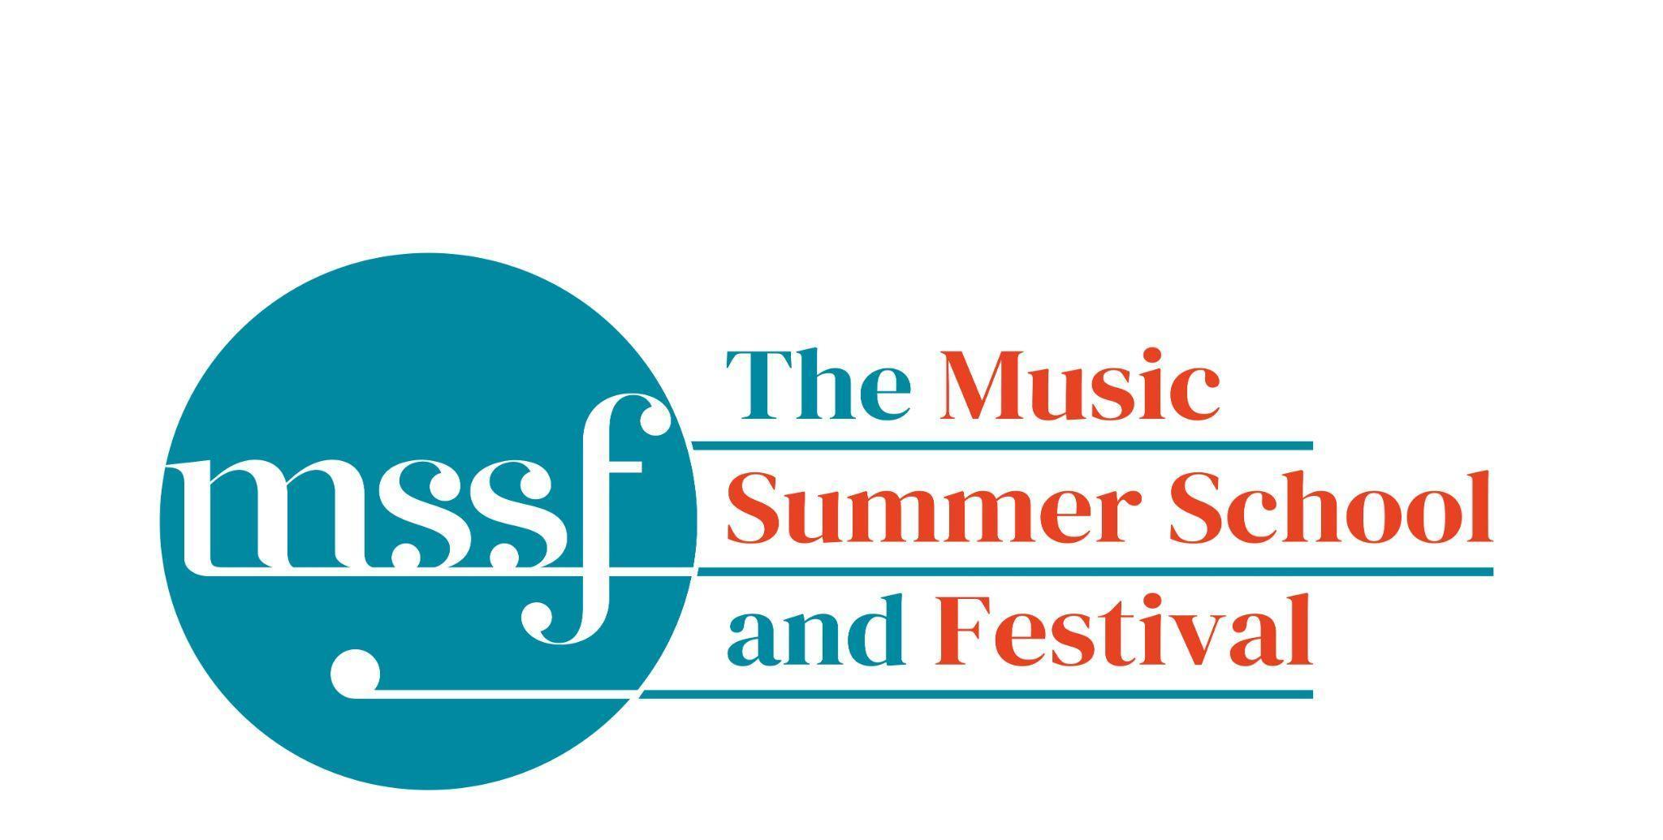

Daily Programme
Monday 4 August 2025

Tai-Chi - Moving Meditation  With Doris Schierer | Chapel Lawn | 7.15am to 7.45am - the gentle exercise of Tai-Chi helps to improve balance and co-ordination.

Session 1 (09:00-10:30)
Choir : Handel - Israel in Egypt  directed by Andrew Griffiths | Chapel | Scores available for hire, or collection if pre-ordered, from the Summer School Office.
Orchestral Workshop  Directed by Rhiannon Evans | D117  Dyson Building
Chamber Music  directed by Rhiannon Evans | Various | Auden Theatre, BS2, D104, D116

Morning Break (10:30 – 11:00)

Session 2 (11:00-12:30)

Organ  directed by David Titterington | Little Walsingham Church | Please note this session starts at 10am today

Vocal Ensembles – The Golden Renaissance  directed by Stile Antico | Various | Please meet at your allocated rooms
Baroque Orchestra  directed by Steven Devine | Big School Hall
Connections : Musical Pathways in Renaissance Europe  directed by The City Musick | Reith Building  New Hall | This is on the second floor.
Voice  directed by Mary Nelson | Elephant Steps
To Stand Up and Sing  directed by Kate Semmens | Britten Building  B9 ‘Greatorex’
Harpsichord  directed by Marco Mencoboni | Big School  BS2 | Please note change of venue.
Collaborative Piano  directed by Anna Tilbrook | Britten Building  Fishmongers’ Hall
Messiaen’s 20 and the twentieth century  directed by Rolf Hind | Auden Theatre | This is just beyond the cafe.
Chamber Music  directed by Rhiannon Evans & The Brook Street Band | Various | Britten Building B18, BS1. D104. D117
Composition : Making a living as a composer  directed by Stephen Montague | Britten Building  B10 ‘Shaw’
Jam Band  directed by Steve Dummer | Big School  BS4

Lunch Break (12:30 – 14:00)
13:15 - 13:50  Try a Viol  directed by Rhiannon Evans | Elephant Steps | Try your hand at this fascinating historical instrument with Rhiannon Evans.  Everyone welcome, no experience needed.

Session 3 (14:00-15:30)
Voices of the Golden Age  directed by Cantoría | Reith Hall  Reith Building | This is on the first floor.
Song  directed by Mary Nelson & Anna Tilbrook | Elephant Steps
Baroque Orchestra  directed by Steven Devine | Big School Hall
Connections: Musical Pathways in Renaissance Europe  directed by The City Musick | New Hall  Reith Building | This is on the second floor.
To Stand Up and Sing  directed by Kate Semmens | Auden Theatre
Harpsichord  directed by Marco Mencoboni | Big School  BS2 | Please note change of venue
Organ  directed by David Titterington | Little Walsingham Church
Jam Band  directed by Steve Dummer | Big School  BS4
Composition : Making a living as a composer  directed by Stephen Montague | Britten Building  B10 ‘Shaw’
Writing for the Piano  directed by Rolf Hind | Fishmongers’ Hall
Chamber Music  directed by Rhiannon Evans & The Brook Street Band | Various | BS1. D104, D105, D106, D116, D117

Session 4 (16:00-17:00)

Sing with Stile – ‘The Italian Job: from Palestrina to Monteverdi’  directed by Stile Antico | Chapel | Please note change of venue
Tenebrae: Sacred Music from the Spanish Golden Age  directed by Cantoría | Big School 4
Baroque Orchestra  directed by Steven Devine | Big School Hall
Chamber Music  directed by Rhiannon Evans | Various | BS2, D104, D116, D117, Fairfield Common Rm
An Introduction to Improvisation  directed by Steve Dummer | Britten Building  B9 ‘Greatorex’
Dark Sun - August 6th, 1945  directed by Stephen Montague | Britten Building  B10 ‘Shaw’

Monday 4 August 2025

Concerts and Talks
17:15  TALK  Simon Kinder | Meet at the Elephant Steps | Explore the storiies of Gresham’s including its famous alumn, Britten, Auden and Berkeley, on this guided tour, led by the school’s Director of History
19:30  CONCERT  Cantoría – El Fuego  Inés Alonso – soprano  Oriol Guimerà – alto  Jorge Losana – tenor and director  Lluís Arratia – bass  Marc de la Linde – viola da gamba  Daniel Murphy – vihuela | Chapel | Desire, passion and sin burns in this celebration. Also does the hearts of the lovers and the flames of the spirit. The Virgin is tempted by the young man, but also gives birth to the divine redemption. The art of the Spanish sixteenth century is full of the contrast between fiery and devotion. It shows a world dwelled by demons, saints and people that lived the same feelings as we live today. Music and Literature in the courtly environment of the Iberian Renaissance will be our gateway to this world. Through the music of some of the most excellent spanish songbooks preserved throughout history, Cantoría approaches to the souls of women and men who experienced vividly the fire of love, solitude, joy and sin.
21:30  CONCERT  Kinga Ujszászi – violin | Chapel | Heinrich Biber – Sonata No 3. (1681) in F major  Johann Paul von Westhoff – Campanella  Biber – Annunciation – Mystery Sonata No.1  Biber – Sonata No. 6 (1681) in C minor  Johann Vilsmayr – Partita No. 5  Biber – The Assumption – Mystery Sonata No.13  Mystery and Mastery offers a glimpse into the dazzling and expressive world of 17th-century violin music—a period when the violin was emerging as a solo instrument of unprecedented virtuosity and emotional depth.

Office Opening Hours (Dyson Building, Room D05):
Saturday | 8.30am - 10am | 2pm – 6.30pm
Sunday | 8.30am - 12.45pm | 1.45pm - 5.30pm
Monday - Friday | 9am – 12.45pm | 1.45pm - 5.30pm
Practice Rooms and Studio Booking Times:
All studios and practice rooms are open 8am – 10pm.
Booking sheets for practice rooms are posted at 1.45pm daily on each practice room for the following day. On Sundays the sheets will be posted at 8.30am for that day. Larger spaces are sometimes available for practice and can be booked with the Summer School Office Manager – please enquire in the Summer School Office in the Dyson Building (Room D0.05) for availability. These can be booked from 1.45pm for the following day (and from 8.30am on Sunday for Sunday bookings).
The instrument store room is located next door to the Summer School Office in the Dyson Building, Room D04.
Cafe and Bar Opening Hours: Tigs Café, situated in the Britten Building, is open from 10am to 4pm every day. The Auden Theatre Bar is open from 4pm to 11pm every day (midnight on Fridays).
Available in the Cafe - Wraps, Cakes, Light Meals - Hot and Cold Drinks - Ice Cream
Wine at dinner is available to purchase by the glass (£6) or bottle (£20) during dinner. Unfinished bottles can be labelled and kept in the fridge so that you can finish it off another evening.
Croquet - the croquet set is available to borrow from the Summer School Office (Dyson Building, Room D05) during office hours.
Swimming - The swimming pool, included in your summer school package, is open from 6.30am-8.30am and from 4pm-6pm.
Alexander Technique - Jonathon Heather is available for 1:1 and group sessions of Alexander Technique ( this is included as part of your summer school package), please book direct with Jonathon Heather in Room D118 in the Dyson Building.

