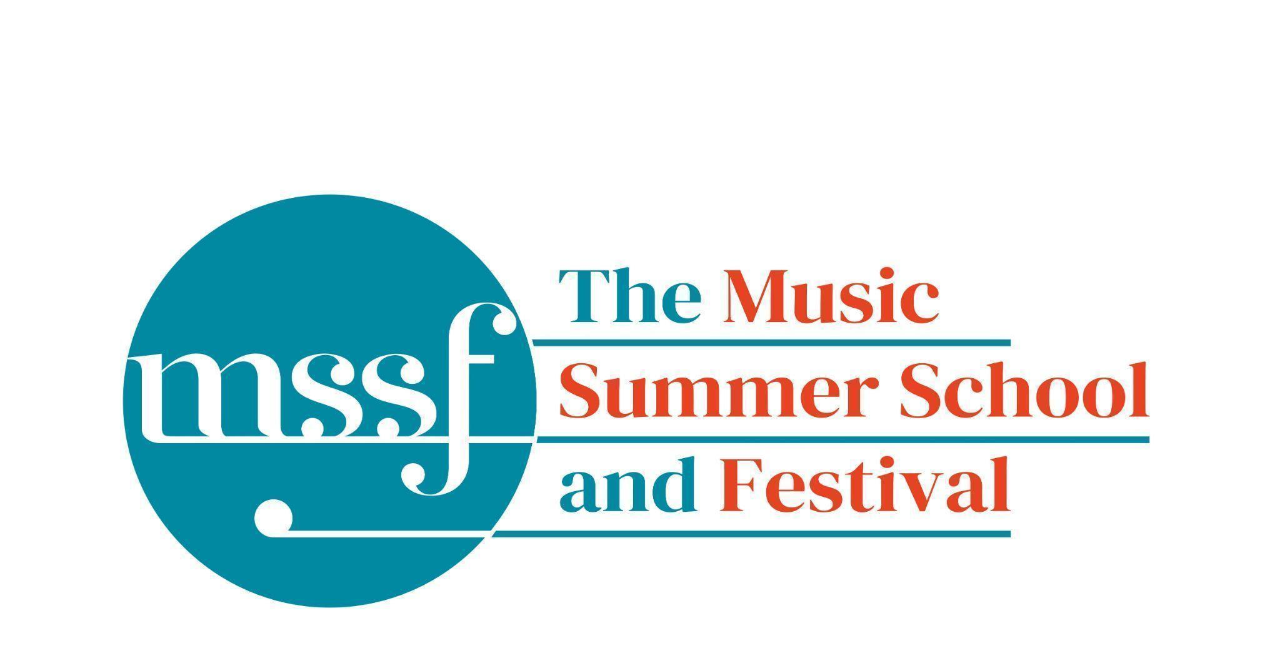

Daily Programme
Friday 8th August 2025

As the week is coming to an end please remember to pop into the office anytime to make a donation for any printing/photocopying you may have done.
If you are checking out please leave your keys and lanyard in the boxes provided in your accommodation.
Read to the bottom for information about Saturday minibuses to the station.
But - there’s still one more jam-packed day to go…
Tai-Chi - Moving Meditation  With Doris Schierer | Chapel Lawn | 7.15am to 7.45am - the gentle exercise of Tai-Chi helps to improve balance and co-ordination.

Session 1 (09:00-10:30)
Choir, Soloists and Baroque Orchestra  Handel - Israel in Egypt  directed by Andrew Griffiths | Chapel | Choir 09:00 - 11:45  Orchestra 09:00 - 12.30  Please arrive at 08:45 to be seated by 09:00
Orchestral Workshop  Directed by Rhiannon Evans | D117  Dyson Building
Chamber Music  directed by Rhiannon Evans | Various | B9 (grand piano), BS1 (harpsichord @ 440), D104, D116

Morning Break (10:30 – 11:00)

Session 2 (11:00-12:30)

Organ  directed by David Titterington | Little Walsingham Church
Vocal Ensembles – The Golden Renaissance  directed by Stile Antico | Various | Please meet at your allocated rooms
Connections : Musical Pathways in Renaissance Europe  directed by The City Musick | Reith Building  New Hall | This is on the second floor.
Voice  directed by Mary Nelson | Elephant Steps
To Stand Up and Sing  directed by Kate Semmens | Britten Building  B9 ‘Greatorex’
Harpsichord  directed by Marco Mencoboni | Big School  BS2
Collaborative Piano  directed by Anna Tilbrook | Britten Building  Fishmongers’ Hall
Messiaen’s 20 and the twentieth century  directed by Rolf Hind | Auden Theatre | This is just beyond the cafe.
Chamber Music  directed by Rhiannon Evans & The Brook Street Band | Various | Britten Building B18, BS1, D104, D117

Lunch Break (12:30 – 14:00)
12:30- 12:50  VOCAL ENSEMBLES INFORMAL SHOWCASE  directed by Stile Antico | Elephant Steps | Everyone welcome!
13:15 - 13:45  CONCERT: 4 x 4 Song Recital  Quartet: Jane Freeman, Hilde Vanachter, Claudia Gamperle & Catherine Rowett  Sharon Reed, Alan Tomlinson, Anna Shiel,  Laura Harry  Piano: Gavin Roberts | Elephant Steps | Shenandoah - trad. arranged by Basler  Piangero La Sorte Mia - Handel  Poème d’amour - Massenet  Eia, mater, fons amoris -Pergolesi  Zueignung - Strauss.  Who Can Sail Without The Wind? - Ešenvalds
13:15 - 13:50  Try a Viol  directed by Rhiannon Evans | D104 | Try your hand at this fascinating historical instrument with Rhiannon Evans.  For those who signed up and any spectators.

Session 3 (14:00-15:30)
Connections : Musical Pathways in Renaissance Europe  directed by The City Musick | Big School Hall | Please note change of venue
Song  directed by Mary Nelson & Anna Tilbrook | Elephant Steps
To Stand Up and Sing  directed by Kate Semmens | Auden Theatre
Harpsichord  directed by Marco Mencoboni | Big School  BS2
Organ  directed by David Titterington | Little Walsingham Church
Jam Band  directed by Steve Dummer | Big School  BS4
Composition : Making a living as a composer  directed by Stephen Montague | Britten Building  B10 ‘Shaw’
Writing for the Piano  directed by Rolf Hind | Fishmongers’ Hall
Chamber Music  directed by Rhiannon Evans & The Brook Street Band | Various | BS1, D104, D105, D106, D116, D117
Voices of the Golden Age  directed by Cantoría | Reith Hall  Reith Building | Please note this session will start at 15:00 before moving to Big School Hall for the Open Session with Sing with Stile

END OF COURSE PERFORMANCE  15:00 - 15:30  City Musick tutors and participants | Big School Hall | Everyone welcome!

Session 4 (16:00-17:00)
OPEN SESSION  Sing with Stile & Tenebrae: Sacred Music from the Spanish Golden Age  directed by Stile Antico and Cantoría | Big School Hall | Everyone welcome!
CHAMBER MUSIC SHOW & TELL  directed by Rhiannon Evans | Elephant Steps | Everyone welcome!
An Introduction to Improvisation  directed by Steve Dummer | Britten Building  B9 ‘Greatorex’

Friday 8th August 2025

Concerts and Talks
17:15  CONCERT  Showcase Concert | Chapel | Featuring short pieces performed by participants from the following courses:  Song, Organ, Harpsichord Course, Piano, Composition
19:30  CONCERT  Israel in Egypt  Summer School Choir  Summer School Baroque Orchestra  Members of Stile Antico  Andrew Griffiths - director | Chapel | The culmination of the Summer School Choir course and the Summer School Baroque Orchestra Course. Handel’s mighty choral epic Israel in Egypt brings the choir centre-stage with its graphic word painting and multicoloured descriptions of the trials and tribulations of this old testament masterpiece.
21:30  Ceilidh & Jam Band | In the bar | An end of week celebration featuring Kate’s Ceilidh Band and Steve’s Jam Band

Minibus Transfers to the station on Saturday for the 09:43 train
The following people have signed up to the minibus. If you are on this list but shouldn’t be, or you are not on it and would like to be, please contact the Summer School office.
Oakeley residents will be picked up at Oakeley at 08:45 and taken to the main car park to pick up more passengers.
David will take Lawns residents directly from Lawns to the station at 09:00
Residents for Farfield, Edinburgh, Howsons, Tallis and Woodlands should be at the main car park at 08:45
Barazani | Aviva |  | Lucas | Leigh |  | Sharman | George
Cabbell | Stephanie |  | Mäntyjärvi | Tuula |  | Smart | Joanna
Cleij | Marjiolein |  | Mäntyjärvi | Jaakko |  | Zosel | Barbara
Cross | Tony |  | Nichols | Martin |  | Gyani | Tattwa
Devine | Steven |  | Nordhuus | Iver |  | Lynn | Eric
Goedecke | Julia |  | Pearce | John |  | Lynn | Laura
Gray | Megan |  | Robinson | Nina |  | Robinson | Martha
Griffiths | Andrew |  | Röhlig | Bernd |  | Thornton | Jan
Hind | Rolf |  | Rowett | Catherine |  | Wong | Shirley
Kentner | Susane |  | Russell | Easter
Kolstø | Kjell |  | Sacco | Kiele
Lameris | Liesbeth |  | Semmens | Kate

Residents for Queens should be at the Sports Centre car park at 08:45
Ball | Diana |  | Jones | Eiluned |  | Pritchard | Sue
Bennett | Alexie |  | Lynch | David |  | Sheldrick | Gillian
Chapman | Annelise |  | Moeller | Susane |  | Vanachter | Hilde
Dochain | Veronique |  | Peel | Patrica

