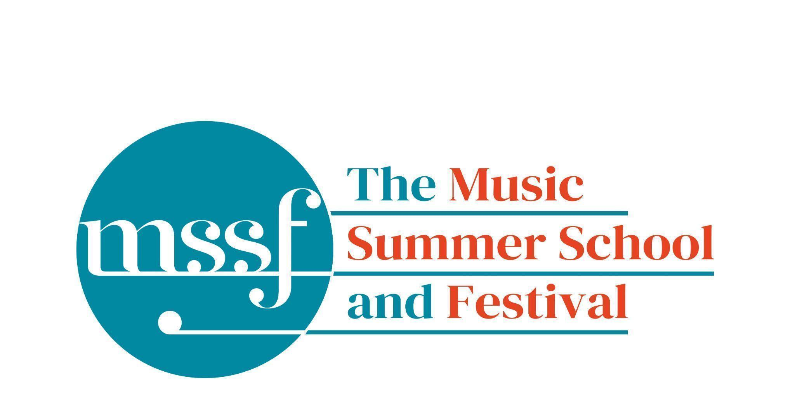
Daily Programme
Friday 15th August 2025

As the week is coming to an end please remember to pop into the office to make a donation for any printing/photocopying you may have done. If you are checking out please leave your keys and lanyard in the boxes provided in your accommodation.
Read to the bottom for very important information about Saturday!
But - there’s still one more jam-packed day to go…

Tai-Chi - Moving Meditation  With Doris Schierer | Chapel Lawn | 7.15am to 7.45am - the gentle exercise of Tai-Chi helps to improve balance and co-ordination.

Session 1 (09:00-10:30)
08:50 - 12:30  Summer School Choir and Orchestra Mendelssohn - Elijah  directed by David Temple | Chapel | Please be seated at 8:45am for a prompt start at 08:50
Chamber Music  directed by Rhiannon Evans | Various | Britten Building 3, 9, 10, 18, 20  Dyson Building D105, D107

Morning Break (10:30 – 11:00)

Session 2 (11:00-12:30)

Chamber Music  directed by Rhiannon Evans & Anna Tilbrook | Various | Britten Building B9,18,20
Song Writing - Songs of the Forest  directed by Anna Anise | Big School 3
Piano  directed by Florian Mitrea | Fishmongers’ Hall  Britten Building
Cello  directed by Michal Kaňka | D107  Dyson Building
Viola  directed by Jakub Čepický | D114  Dyson Building
Violin  directed by Leoš Čepický | D105  Dyson Building

Lunch Break (12:30 – 14:00)

12:30 - 12:50  Songwriters Showcase | Elephant Steps | A performance of songs written during the week on the Song Writing Course directed by Anna Anise
13:00 - 14:00  Chamber Music Show & Tell | Fishmongers’ Hall | A performance of works from the Chamber Music Course directed by Rhiannon Evans
13:15 - 13:30  Encore Cafe | Big School Hall | A performance of songs from the Encore Cafe directed by Sarah Gabriel and Huw Wiggins

Session 3 (14:00-15:30)
Chamber Music  directed by Rhiannon Evans, Anna Tilbrook, Wihan Quartet | Various | Britten Building - B9, B20  Dyson Building - D105, D107
Voice  directed by James Platt | D114  Dyson Building
Voice  directed by Sarah Gabriel | Elephant Steps  Dyson Building
Opera Ensemble and Orchestra  directed by Pippa Dames Longworth,  Ian Rutherford, Andrew Smith and Steve Dummer | Auden Theatre | Dress rehearsal  Please note - this session will start at 14:30 and end at 16:30
Percussion  directed by Simon Limbrick | B1  Britten Building | Please note this rehearsal for Vinko Globokar ‘Tribadabum Extensif Sur Rhythm Fantome 3’  will start at 13:30
Saxophone  directed by Huw Wiggin | B10  Britten Building
Trumpet  directed by Paul Archibald | B17  Britten Building
Horn  directed by Jacqueline Kershaw | B18/19  Britten Building
Clarinet  directed by Catriona Scott | D105  Dyson Building
Oboe  directed by Adrian Wilson | D106  Dyson Building
Flute  directed by Jenny Farley | D116  Dyson Building
Bassoon  directed by Kim Murphy | D117  Dyson Building
Double Bass  directed by Leon Bosch | Big School Hall | Please note change of time and venue
Song Writing - Songs of the Forest  directed by Anna Anise | BS3  Big School
Piano  directed by Florian Mitrea | Fishmongers Hall  Britten Building

Session 4 (16:00-17:00)
Chamber Music  directed by Rhiannon Evans, Anna Tilbrook, | Various | Britten Building - B3, B9, B10, B20  Dyson Building - D105, Fishmongers’ Hall

Friday 15th August 2025
Concerts and Talks
16:30  CONCERT  Summer School Percussion Ensemble  directed by Simon Limbrick | The Chapel Lawn | Vinko Globokar - “Tribadabum Extensif Sur Rhythme Fantôme 3”  Followed by the procession to the Theatre in the Woods
17:15 - 18:00  CONCERT  Summer School Wind Band  directed by Steve Dummer | Theatre in the Woods | Programme to include:  Ernest Tomlinson - Suite of English Folk Dances  Joseph Horovitz - Fête Galante
19:30  CONCERT  Summer School Choir and Orchestra  directed by David Temple | Chapel | Mendelssohn - Elijah  Linda Richardson (soprano)  Rebecca Afonwy-Jones (alto)  Tom Elwin (tenor)  James Platt (bass)
21:30  CONCERT  Summer School Opera Ensemble and Orchestra | Auden | Excerpts from The Magic Flute - Mozart  directed by Pippa Dames Longworth, Ian Rutherford, Andrew Smith and Steve Dummer

Saturday 16th August 2025
The swimming pool will not be open on Saturday morning.
Please leave your keys and lanyards in the boxes provided in the accommodation.
Minibus Transfers to Sheringham station on Saturday for the 09:43 train
Oakeley residents will be picked up at Oakeley at 08:45 and taken to the main car park to pick up more passengers.
David will take Lawns residents directly from Lawns to the car park for 08:45
Residents for Farfield, Edinburgh, Howsons, Tallis and Woodlands should be at the main car park at 08:45
Tilbrook | Anna |  | Zupan | Alma |  | Stewart | Marion
Robinson | Yvonne |  | Crump | Diana |  | Veal | Andrew
Arnold | Steve |  | Griffiths | Peter |  | White | Jenny
Secular -Faber | Rachel |  | King | Judith |  | Zosel | Barbara
Haynes | Barbara |  | Roberts | Gavin |  | Shaw | Susan
Donaldson | Julie |  | Rogers | Barnaby |  | Wiggins | Huw
Jackson | Anita |  | Stewart | Marion
Mckenna | Hilde |  | Stewart | Charles
Teng | Josephine |  | Chown | Ian
Longden | Janet |  | Carr | Tom

The 78th Summer School will run at Gresham’s from 1st to 15th August 2026. An outline programme will be available in early September when Priority Booking will open.
Safe travels! We look forward to seeing you next year.

