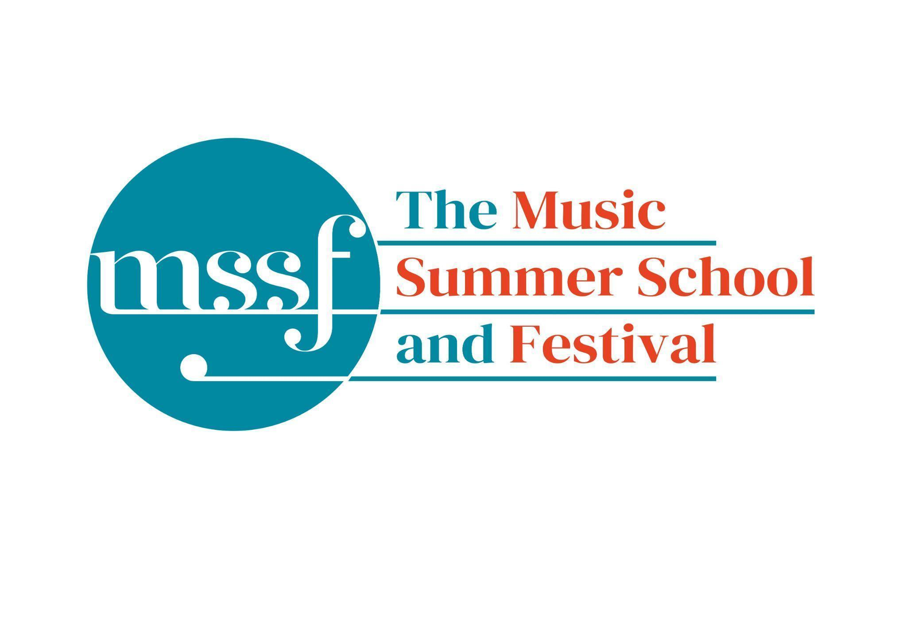

**Daily Programme**

**Wednesday 31 July 2024**

**Session 1 (09:00-10:30)**

| **Choir – Bach’s St John Passion**  directed by Andrew Griffiths | Chapel |  |
| --- | --- | --- |
| **Chamber Music**  directed by Rhiannon Evans | Dyson Building D1.04, D1.07  Big School 1, 3 | Please see separate notice for groups in Dining Room and Summer School office and on Whova in the photos section |
| **Baroque Orchestra - continuo and James Gilchrist** | Big School  Hall | This session is just for harpsichordists and cellists |

**Morning Break (10:30 – 11:00)**

**Session 2 (11:00-12:30)**

| **Vocal Ensembles – A Pilgrim’s Journey**  directed by Stile Antico | Dyson Building D1.14, D1.16, D1.17, D118  Britten Building 10, 20  Big School 3, 4  Chapel | Please go to the rooms with the groups that you were allocated to yesterday. |
| --- | --- | --- |
| **Music from Renaissance Italy**  directed by The City Musick | Reith Building  Reith Hall, New Hall and New Hall 2 | There is a lift to all floors to the left of the main entrance. |
| **Baroque Chamber Music**  directed by The Brook Street Band | Dyson Building  Room D1.04 | This is on the first floor. There is a lift at the back of the building. |
| **Harpsichord Course**  directed by Skip Sempé | Big School  Room 1 |  |
| **Cataloguing Birds**  directed by Rolf Hind | Britten Building  Fishmongers’ Hall | This is just beyond the cafe. |
| **Organ Course**  directed by David Titterington | Little Walsingham Church |  |

**Lunch Break (12:30 – 14:00)**

**Session 3 (14:00-15:30)**

| **Song Course**  directed by James Gilchrist and Anna Tilbrook | Britten Building  Fishmongers’ Hall | This is just beyond the cafe. |
| --- | --- | --- |
| **To Stand Up and Sing – Vocal Workshop**  directed by Kate Semmens | Auden Theatre |  |
| **Baroque Orchestra**  directed by Steven Devine | Chapel | Please note that this rehearsal will run from 1.30pm to 4.30pm |
| **Crossroads and Catalysts**  directed by Ensemble Tempus Fugit | Britten Building  Room 18/19 | This is on the first floor. There is a lift in the cafe. |
| **Music from Renaissance Italy**  directed by The City Musick | Reith Building  Reith Hall, New Hall and New Hall 2 | There is a lift to all floors to the left of the main entrance. |
| **Harpsichord Course**  directed by Skip Sempé | Big School  Room 1 |  |
| **Cataloguing Birds**  directed by Rolf Hind | Britten Building  Room 10 | Please note that this is in a different venue to the morning session. |

**Session 4 (16:00-17:00)**

| **Sing with Stile – Purcell and Friends**  directed by Stile Antico | Auden Theatre |  |
| --- | --- | --- |
| **Chamber Music**  directed by Rhiannon Evans | Dyson Building D1.06  Big School 1  Britten Building 17 | Please see separate notice for groups in Dining Room and Summer School office and on Whova in the photos section |
| **Baroque Chamber Music**  directed by The Brook Street Band | Dyson Building D1.04, D1.07  Big School 3 | These rooms are on the first floor, there is a lift at the back of the building |
| **Revelry and Refinement – Medieval Winds & Wires**  directed by Emily Baines | Dyson Building  Room D1.14 | This is on the first floor. There is a lift at the back of the building. |
| **Playing the Changes – Improvising in Period Style**  directed by Jamie Akers | Dyson Building  Room D1.05 | This is on the first floor. There is a lift at the back of the building. |
| **Alexander Technique for Musicians**  directed by Jonathon Heather | Dyson Building  Room D1.18 | This is on the first floor. There is a lift at the back of the building. |

**Wednesday 31 July 2024 - Concerts and Talks**

| **17:15**  **CONCERT**  **David Titterington - organ** | Church of St Mary and All Saints  Little Walsingham | Georg Muffat – Toccata decima  Johann Caspar Kerll – Passacaglia  Vincent Lúbeck – Praeludium in E major  Heinrich Scheidemann – Dic nobis Maria [intabulation after Bassano]  J S Bach – Prelude and Fugue in E minor BWV 548  Nadia Boulanger – Prelude in F minor  Franz Schmidt – O, wie selig seid ihr doch, ihr Frommen  Felix Mendelssohn-Bartholdy – Prelude and Fugue in D minor |
| --- | --- | --- |
| **19:30**  **CONCERT**  **Suite of Suites**  Summer School Baroque Orchestra  Steven Devine - director | Chapel | Georg PhilippTelemann – Overture-Suite in C TWV 55:C3 “Hamburger Ebb’ und Fluth” Johann Bernhard Bach – Overture in D Jean-Philippe Rameau – Suite from Hyppolite e Arice Georg Philipp Telemann – Conclusion in Bb (Tafelmusik 3) TWV 50:10  Telemann’s 1723 evocation of the sea in all its moods opens this concert from the Summer School Baroque Orchestra. Written for a civic celebration in the trading city of Hamburg, Telemann masterfully depicts the ebb and flow of the sea and portrays many maritime mythological tableaux throughout this suite of dances. JB Bach (rather overshadowed by his illustrious and almost exact contemporary cousin) served the court of Eisenach where he composed music that showed the influence of both French and German tastes. His music is the perfect bridge to that of the 18th century French master, Rameau, whose music from his first opera, written when he was almost 50 years old, we hear next. The concert closes with a return to Telemann and the ebullient ‘Furioso’ finale of perhaps his most famous work, the ‘Tafelmusik’. |
| **21:30**  **CONCERT**  **Rolf Hind - piano** | Auden Theatre | Rolf Hind – Bhutani – Etudes on the names of animals in Sanskrit No.6 Avatara – he who descends No.7 Bhujanganam – “winding-going” – a snake No.8 Khaga – “sky-gone” – a bird  Maurice Ravel – Noctuelles; Oiseaux Tristes (from Miroirs) Olivier Messiaen – Le Loriot from Catalogue d’Oiseaux Claude Debussy – Prelude: La Terrasse des Audiences au clair de Lune. Judith Weir – The Art of Touching the Keyboard Messiaen Le Courlis Cendre and Le Traquet Rieur from Catalogue d’Oiseaux  A recital exploring how composers have responded to the influences of birds and animals in music. Some composers have tried to emulate the calls of birds and animals in their music; some have been inspired to create music of beauty, fear, peace, or balance through their study of the natural world. Some have used the sound world of birdsong to create their own musical language. Composer and pianist Rolf Hind explores these varied approaches, and includes his own response through movements from his Etude collection based on the Sanskrit names of animals. |

**Important Information**

**Office Opening Hours:**

| **Saturday** | **8.30am - 10am** | **2pm – 6.30pm** |
| --- | --- | --- |
| **Sunday** | **8.30am - 12.45pm** | **1.45pm - 5.30pm** |
| **Monday - Friday** | **9am – 12.45pm** | **1.45pm - 5.30pm** |

**Practice Rooms and Studio Booking Times:**

All studios and practice rooms are open 8am – 10pm.   
Booking sheets for practice rooms are posted at 5pm daily on each practice room for the following day. On Sundays the sheet will be posted at 8.30am for that day.   
Larger spaces are sometimes available for practice and can be booked with the Summer School Office Manager – please enquire in the Summer School Office in The Dyson Building (Room D0.05) for availability. These can be booked from 1.45pm for the following day (and from 8.30am on Sunday for Sunday bookings).

**Cafe and Bar Opening Hours:**

Cafe: 10am – 5.15pm Bar: 4pm – 11pm (12am on Fridays) Food Truck: 8pm – 11pm

Available in the Cafe - Hot Smoked Salmon Pate, Strawberries and Chantilly, scotch eggs, quiche, wraps, salad, scones, cakes, ice lollies and much more

**Wine at dinner** is available to purchase by the glass (£6) or bottle (£20) during dinner. Unfinished bottles can be labelled and kept in the fridge so that you can finish it off another evening.

**Croquet -** the croquet set is available to borrow from the Summer School Office (Room D0.05) during office hours.

**Please check the notice board in the Dining Room for sign up sheets for the following events:**

**Cataloging Birds -** Early morning listening walk on the 1st August