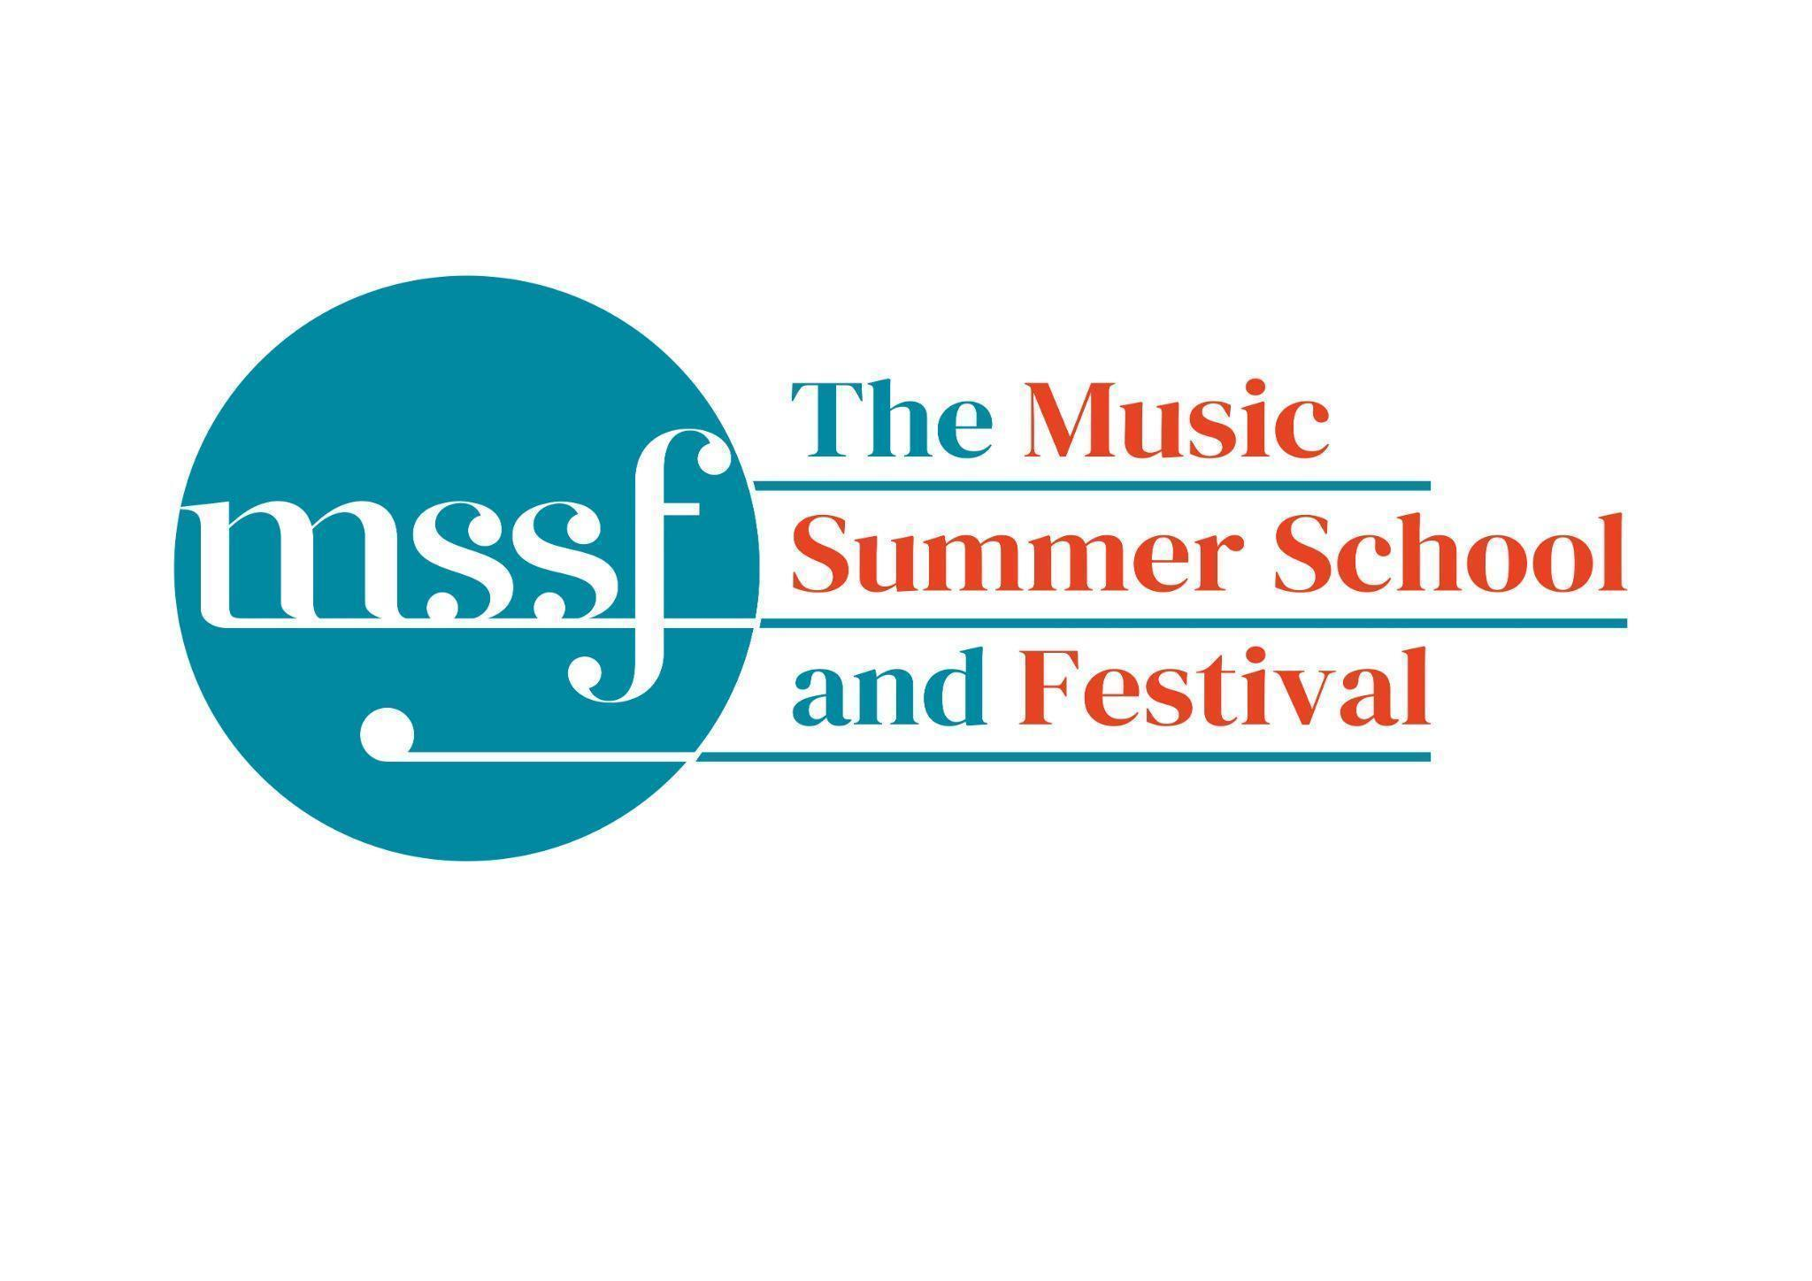

**Daily Programme**

**Thursday 8 August 2024**

| **7:30 - 8:00**  **Alexander Technique**  with Jonathon Heather | D1.18 | A daily, early morning half hour for a moment of "constructive rest /semi -supine" as a way to offer a chilled and restorative start to the day for those who would like it. Yoga mats provided. |
| --- | --- | --- |

| **Summer School Feedback Survey** | Whova app | The survey on Whova is live and we’d be so grateful for your feedback. If you are not registered on Whova and would like a link to the survey or a paper copy, please come to the Summer School office |
| --- | --- | --- |

**Session 1 (09:00-10:30)**

| **Choir – Mozart’s Requiem**  directed by Stephen Layton | Chapel |  |
| --- | --- | --- |
| **Brass Ensembles**  directed by Roger Argente and Paul Archibald | Reith Building  Reith Hall |  |
| **Chamber Music and Advanced Chamber Music**  directed by Rhiannon Evans, Leon Bosch, Judith van Driel, David Faber and Anna Tilbrook | Various/  Fishmonger Hall | Please see separate notice in Dining Room, Summer School office and on Whova |
| **Advanced Wind Ensemble -** Mozart ‘Gran Partita’  directed by Alasdair Hill | Big School  Hall |  |
| **Keyboard Course**  directed by Mahan Esfahani | Auden Theatre | Please note change of venue |

**Morning Break (10:30 – 11:00)**

**Session 2 (11:00-12:30)**

| **Chamber Choir**  directed by Gavin Roberts | Auden Theatre |  |
| --- | --- | --- |
| **Wind Band**  directed by Steve Dummer | Big School Hall | The rehearsal on Friday will take place in the Theatre in the Woods |
| **Violin and Viola Course** directed by Judith van Driel | Reith Building  Reith Hall |  |
| **Cello Course**  directed by David Faber | Big School  Room 1 |  |
| **Double Bass Course**  directed by Leon Bosch | Britten Building  B9 |  |
| **Piano Course**  directed by Florian Mitrea | Fishmongers Hall |  |
| **Keyboard Course**  directed by Mahan Esfahani | Dyson Building  Elephant Steps |  |
| **Making in Sound and Vision**  directed by Stephen Montague and Alex Julyan | Dyson Building  Art Rooms |  |

**Lunch Break (12:30 – 14:00)**

| **13:05 - 13:45**  **Home**  directed by Yshani Perinpanayagam | Dyson Building  Elephant Steps | Rehearsal for the world premier of Home by Yshani. Everyone is welcome, everyone can join in, please all bring something to make a noise with - an instrument, something to bang, your voice. The performance is at 4.00pm on Friday in Fishmongers Hall. |
| --- | --- | --- |

**Session 3 (14:00-15:30)**

| **Opera Ensembles**  directed by Pippa Dames Longworth, Ian Rutherford and Andrew Smith | Auden Theatre | Please note this session is from 14:00 - 16:45. The Opera Ensemble Orchestra will join the singers at 15:45. |
| --- | --- | --- |
| **Voice Course**  directed by Ruby Hughes | Dyson Building  Elephant Steps |  |
| **Voice Course**  directed by Sarah Gabriel | Reith Building  Reith Hall |  |
| **String Ensemble**  directed by Leon Bosch | Big School  Hall |  |
| **Piano Course**  directed by Florian Mitrea | Fishmongers Hall |  |
| **Flute Course**  directed by Alena Walentin | Big School  Room 3 |  |
| **Oboe and Bassoon Course**  directed by Alasdair Hill | Britten Building  B10 | Please note that Ashley Myall will be unable to teach this session due to rehearsal. The bassoons will join the oboes. |
| **Clarinet Course**  directed by Anna Hashimoto | Britten Building  B9 |  |
| **Horn Course**  directed by Chris Beagles | Big School  Room 4 | Please note this session will end early due to rehearsals. |
| **Trumpet Course**  directed by Paul Archibald | Britten Building  Room B17 |  |
| **Trombone Course**  directed by Roger Argente | Britten Building  B18/19 |  |
| **Saxophone Course**  directed by Huw Wiggin | Britten Building  B20 |  |
| **Making in Sound and Vision**  directed by Stephen Montague and Alex Julyan | Dyson Building  Art Rooms |  |
| **Mozart Requiem and Britten Serenade rehearsal for orchestra only**  directed by Stephen Layton | Chapel | 14:00 - 15:15 - Mozart Requiem  15:30 - 17:00 - Britten Serenade for strings, tenor and horn |

**Session 4 (16:00-17:00)**

| **Songs of Travel**  directed by Sarah Gabriel | Reith Building  Reith Hall |  |
| --- | --- | --- |
| **Opera Ensembles Orchestra**  directed by Steve Dummer | Auden Theatre | Please note change of venue. This session is with the singers from 15:45 - 16:45 |
| **Open Composition**  directed by Yshani Perinpanayagam | Edinburgh Common Room | You will need a code to access Edinburgh Common Room. Please ask at the Summer School office if you need the code. |
| **Chamber Music**  directed by Rhiannon Evans | Various |  |
| **Alexander Technique for Musicians**  directed by Jonathon Heather | Dyson Building  D1.18 | This is on the first floor. There is a lift at the back of the building. |

**Thursday 8 August 2024**

**Concerts and Talks**

| **17:15**  **CONCERT**  **Summer School Chamber Choir**  directed by Gavin Roberts | Fishmongers | Gavin Roberts & Tom Carr – piano  Brahms – Liebeslieder Waltzes  and music for piano duet |
| --- | --- | --- |
| **19:30**  **CONCERT**  **Summer School String, Wind and Brass Ensemble**  Directed by Leon Bosch, Paul Archibald, Roger Argente and Alasdair Hill | Chapel Green,  Auden Theatre,  Big School Hall | **Please note timings and venues**  Music for Brass Ensemble on Chapel Green at 7.30pm  Alexander Arutiunian - Sinfonietta for String Ensemble in Auden Theatre at about 8.00pm  Mozart – Serenade No. 10 for winds in Bb, K361/370a ‘Gran Partita’ in Big School Hall at about 8.30pm  Concert ends at about 9.20pm |
| **21:30**  **CONCERT**  **Summer School Showcase Concert** | Chapel | A showcase performance of participants at the summer school. Including students from the Keyboard, Piano, Wind and Brass courses |

**Important Information - honestly, this is important, please read.**

The following people have signed up to the minibus, If you are on this list but shouldn’t be, or you are not on it and would like to be, please contact the Summer School office by 11.00am today (Thursday)

| Andela Anne-Sophie | Montague Stephen | Thomas Judith |
| --- | --- | --- |
| Chown Ian | Perinpanayaga Yshani | Thomas Benjamin |
| Cleij Marjolein | Rasova Krystina | Van De Keere Aude |
| Galagher Lyndsay | Richards Clara | White Jenny |
| Julyan Alex | Roberts Gavin | Wiggin Huw |
| King Judith | Stewart Charles | Wong Dexter |
| Landsborough Ian | Stewart Marion | Zosel Barbara |
| Leung Marcus | Teng Josephine |  |

You are invited to take part in a performance of Stephen Montague’s Intrada 1631 on Friday 9 August at 5.15pm in the Theatre in the Woods. All you need is a triangle. Special edition souvenir Music Summer School and Festival triangles will be available at the Summer School office from 8.30am on Friday morning, for a donation.

**Office Opening Hours:**

| **Saturday** | **8.30am - 10am** | **2pm – 6.30pm** |
| --- | --- | --- |
| **Sunday** | **8.30am - 12.45pm** | **1.45pm - 5.30pm** |
| **Monday - Friday** | **9am – 12.45pm** | **1.45pm - 5.30pm** |

**Practice Rooms and Studio Booking Times:**

All studios and practice rooms are open 8am – 10pm.   
Booking sheets for practice rooms are posted at 5pm daily on each practice room for the following day. On Sundays the sheet will be posted at 8.30am for that day.   
Larger spaces are sometimes available for practice and can be booked with the Summer School Office Manager – please enquire in the Summer School Office in The Dyson Building (Room D0.05) for availability. These can be booked from 1.45pm for the following day (and from 8.30am on Sunday for Sunday bookings).

**Cafe and Bar Opening Hours:**

Cafe: 10am – 5.15pm Bar: 4pm – 11pm (12am on Fridays) Food Truck: 8pm – 11pm

Available in the Cafe - Hot Smoked Salmon Pate, Strawberries and Chantilly, scotch eggs, quiche, wraps, salad, scones, cakes, ice lollies and much more

**Wine at dinner** is available to purchase by the glass (£6) or bottle (£20) during dinner. Unfinished bottles can be labelled and kept in the fridge so that you can finish it off another evening.

**Croquet -** the croquet set is available to borrow from the Summer School Office (Room D0.05) during office hours.